**Transport arrangements Uttoxeter Route from September 2023 to July 2024**

# The journey to and from the bus stop

* Students will have to make their own way to the bus stop. The journey to and from the bus stop may contain a number of hazards to pedestrians. Walking the same route on a daily basis means that it is very easy to become complacent about the dangers it presents.
* Please remind your child of the following to help them make the journey to and from the bus stop safer.
* Where possible, walk as part of a group but remember that your safety is your own responsibility, not your friends.
* If you are wearing dark coloured clothing, please be aware that it will be difficult for drivers to see you, particularly when it's dark. Where possible, wear something bright during the day and also wear something reflective when it is dark.
* Use of mobile phones and iPods whilst walking will mean that you are not paying full attention to the road environment. If you do use them whilst walking, please be extra vigilant and pay attention when crossing the road.
* Pedestrian crossings are there for a reason. Please use them.
* Some people think it's OK to mess around on the roads and show off to friends. Remember that you will come off worse if hit by a vehicle.
* Each of us has a responsibility to ourselves to be safe on the road. You can help avoid being a pedestrian casualty if these simple precautions are taken.

# Waiting for the bus

* Arrive at the bus stop in good time − the bus can't wait for you.
* If the bus is late, wait for up to 20 minutes before making alternative arrangements. Students and parents should have a back-up plan in case the bus is very late, or does not turn up.
* Students who miss the afternoon bus should report to a member of staff
* For your own safety and those around you, don't mess around near the road.
* When the bus is approaching, stand well back from the edge of the kerb. Signal the bus to stop by putting out your arm.
* Don't rush for the door when the bus has stopped.
* Students should respect the property of those who live next to, or nearby, the bus stop.

# On the bus

* If you have a bus pass, always have it ready and show it to the driver.
* Find a seat quickly and remain in it during the journey.
* If a seatbelt is available you must wear it throughout the journey.
* If you have to stand during the journey, move well down the bus. Never stand near the driver as you may block his or her view.
* Respect other passengers and the driver.
* All students should behave on the journey to and from school.
* It is illegal for anybody to smoke on all buses and coaches. The use of e-cigarettes is also forbidden.
* Students must only open the emergency door if there is a real emergency. It is extremely dangerous to attempt to open the door when the bus or coach is moving.
* In the event of a breakdown, follow the advice of the driver.

# Behaviour on school transport

* We are committed to providing safe and reliable transport. A number of vehicles have CCTV fitted and images can be made available to the school, or police, on request.

**Dealing with misbehaviour**

# Step one

* Where issues exist, the driver will normally speak to the student(s) about their behaviour. If problems remain, details will be reported to the school. Once a student has been reported, a verbal warning will normally be given by the school. Students may be punished within school for their misbehaviour.

# Step two

* Where a student is a persistent offender or commits a serious offence, a written warning will be issued as follows. Either:
* A letter will be sent home informing parents or guardians of their child's behaviour along with a warning that further misbehaviour will result in the child being banned from the bus for a temporary period. or
* A letter will be sent home informing parents or carer that an immediate ban from the bus has been imposed for a specified period. Students may also be asked to sign an acceptable behaviour contract before they are allowed to return to the bus.
* In very serious cases, the right to travel on school transport may be indefinitely withdrawn. Parents will have a right of appeal, to the Local Governing Body, against the withdrawal of transport provision.
* Parents and guardians should be aware that when bans are imposed, travelling arrangements and costs will become a parental responsibility, the school will not be required to offer any alternative transport assistance when a bus pass has been removed.
* Serious offences may also be reported to the police, to be dealt with by way of criminal proceedings.
* A serious offence can be defined as any type of behaviour which endangers the safety of other passengers, the driver and members of the public. It also includes criminal damage or vandalism to the bus.

## Damage or vandalism on the bus

* Parents or guardians of any student who damages or vandalises the bus will be liable for any costs incurred by the bus company. We will support the bus company and will encourage police involvement if necessary.

## Reporting problems with the school bus

* Initially, problems should be reported to the school office. To help with any investigations, it would help if as much information as possible can be given such as the number of the bus, date, time and details of the problem. It is advisable to make a note of the name of the bus company and their telephone number as you may need to contact them, for example, when tracing lost property.
* Transport provision is based on a standard school year (39 weeks less insets). No refunds will be issued for “snow days” or other events i.e. breakdowns and road closures, that are out of the control of the contractor.

**The route is contracted by ACT for 2023/24, can be contacted on 01335 300670 out of school hours.**

**Route Plan**

*All pick-ups will be on-route only.*

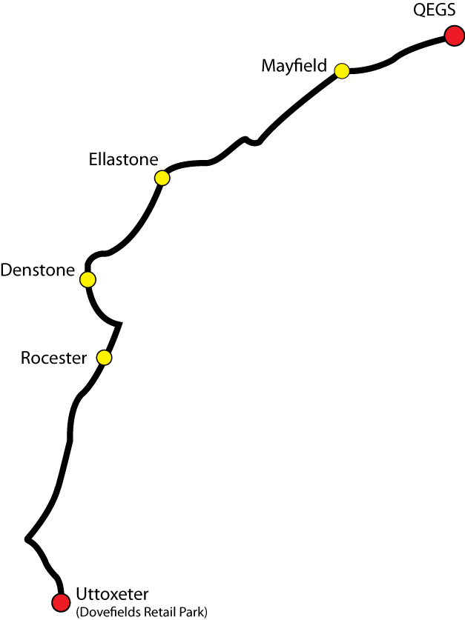

|  |  |  |  |
| --- | --- | --- | --- |
| **Location** | **Pick up AM** | **School finish at 15:20 for bus travel** | |
| Ashbourne CT Depot Depart | 07:30 | |  |
| Uttoxeter, Dovefields Retail Park/Tesco | 07:50 | | 16:20 |
| Rocester, Petrol Station | 08:05 | | 16:05 |
| Denstone, Village shop | 08:14 | | 15:55 |
| Ellastone, Bus shelter opp. Pub | 08:20 | | 15:47 |
| Mayfield, Bus stop on same side of the road as school | 08:27 | | 15:40 |
| QEGS, Ashbourne | 08:40 | | 15:25 |

For further details contact: Mrs C Bramwell enquiries@qegs.email