Application for transport – Uttoxeter Route
Application for a place on route (Uttoxeter, Rocester, Denstone, Ellastone, QEGS)
Places on this route are strictly limited to 16 students. Places will be awarded at the discretion of the Academy. Priority will be given to students travelling on a full time basis.

Contact Details
Name of Student
Date of Birth
School Year 2020/21
Bus stop choice
Parent/Carer Name
Address
Telephone
Email

Preferred Method of Payment
Single Payment of £625.00 to be paid by Friday 11th September 2020. | Yes ☐ No ☐
£70.00 deposit via Parent Pay to secure a seat (by Friday 11th September) and 9 Monthly instalments via Parent Pay of £70.00 [£700.00 in total payable on 1st of the month from 1st October 2020 – 1st June 2021) | Yes ☐ No ☐

Payment will be either a single payment by Friday 11th September 2020 or a deposit of £70.00 followed by 9 monthly instalments of £70.00 on the 1st of the month from October 2020 to June 2021, via Parent Pay. By ticking the consent on Parent Pay and applicants are committed to all 9 monthly payments or the place on the bus will be withdrawn Please return form to:
Mrs C Bramwell:
Via Post : Queen Elizabeth’s Grammar School, The Green Road, Ashbourne, Derbyshire, DE61EP. - Via email : enquiries@qegs.email

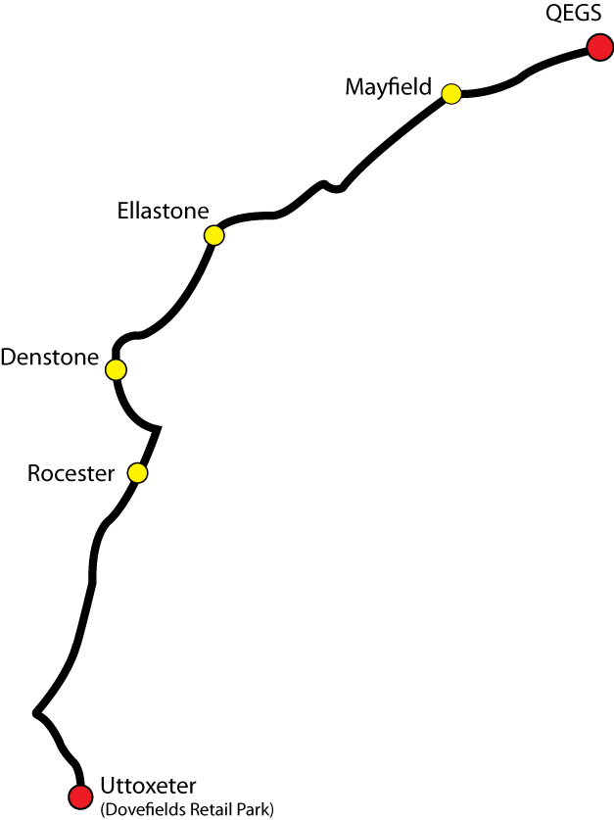

Route Plan

Location | Pick up/Drop off Times
Ashbourne CT Depot Depart | 07:30 |  | 17:10
Uttoxeter | 07:55 |  | 16:45
Rocester, Petrol Station | 08:05 |  | 16:35
Denstone, Village shop | 08:15 |  | 16:25
Ellastone, Bus shelter opp. Pub | 08:20 |  | 16:20
Mayfield, Bus stop on same side of the road as school | 08:30 |  | 16:10
QEGS, Ashbourne | 08:40 |  | 16:00

