GCSE → A Level Biology transition

Answers to maths skills practice questions

1 Numbers and units
- a 1 kJ = 1000 J, so 4 500 000 J = 4 500 000/1000 kJ = 4500 kJ b 1 MJ = 1000 kJ, so 4500 kJ = 4.5 MJ
- 1 m = 10⁹ nm (there are a billion nanometre in a metre)
9.0 × 10⁻⁸ m = 9.0 × 10⁻⁸ × 10⁹ nm = 9.0 × 10⁻⁸ ⁺ ⁹ nm = 9.0 × 10 nm = 90 nm
1.20 × 10⁻⁷ m = 1.20 × 10⁻⁷ × 10⁹ nm = 1.20 × 10⁻⁷ ⁺ ⁹ nm = 1.20 × 100 nm = 120 nm
Range = 90 nm to 120 nm
- a 10¹¹ b 10¹²
c 1000 + 1000 = 2000 d 100 − 0.01 = 99.99
- a 10¹ or 10 b 10⁻³ or 0.001
c 10⁶ or 1 000 00 d 100² ÷ 100 = 100 or 10²
- a 4 mm b 130 s
c 31 300 µl d 0.000 104 mg
- a 57 µm b 8.6 L or 8.6 dm³
c 68 s d 0.09 mm

2 Decimals, standard form, and significant figures
- 0.0214 cm² 0.0218 cm² 0.03 cm² 0.034 cm²
- 12.03 cm 12.901 cm 22 cm 22.003 cm 22.25 cm
- a 3.06×10³ kJ b 1.4×10⁵ kg
c 1.8×10⁻⁴ m d 4×10⁻⁶ m
- a 1×10² b 1×10⁴
c 1×10⁻² d 2.1×10⁷
- Give the following as decimals.
a 1 000 000 b 4 700 000 000
c 1 200 000 000 000 d 0.000 796
- a 7600 g / 7640 g b 28 m / 27.5 m
c 4.3 g / 4.33 g d 6.0 × 10² m / 5.00 × 10² m
- 1.2 × 10⁴ g

3 Working with formulae
- M? I = 6.6 mm O = 165 μm
Change to same units: either both mm or both μm or both m: 165 μm = 0.165 mm
M = I/O = 6.6/0.165 = × 40
- Area = 0.5 × 2 cm × 9 cm = 9 cm²
- Area = π r² = π × (0.7 μm)² = π × (0.7 × 10⁻⁶ m) × (0.7 × 10⁻⁶ m) = 1.5 μm²
- N₀ = 24
7 days = 7 × 24 hours = 168 hours
so n = 168 ÷ 20 = 8.4
Nt = 24 x 28.4 = 8107 cells
- N = 96 + 4 + 22 + 3 = 125 animals found
so $D=1−\sum{{\left(\frac{n}{N}\right)}^{2}}$
inner brackets: $D=1−\left({\left(\frac{\text{96}}{\text{125}}\right)}^{2}+{\left(\frac{4}{\text{125}}\right)}^{2}+{\left(\frac{\text{22}}{\text{125}}\right)}^{2}+{\left(\frac{3}{\text{125}}\right)}^{2}\right)$
indices: $D=1−\left(0\text{.}{\text{768}}^{2}+0\text{.}{\text{032}}^{2}+0\text{.}{\text{176}}^{2}+0\text{.}{\text{024}}^{2}\right)$
addition: D = 1 − 0.6224 = 0.3776 = 0.38 (2.d.p)
- O = 0.1 mm I = ? M = 50 I = M × O = 50 × 0.1 mm = 5 mm
- Area = 5.3 cm² radius? A = π r²
5.3 = π r² r² = $\frac{5\text{.}3}{π}$= 1.687 r = $\sqrt{1\text{.}\text{687}}$ = 1.3 cm
Or A = π r² r² = $\frac{A}{π}$ r = $\sqrt{\frac{A}{π}}$ r = $\sqrt{\frac{5\text{.}3}{π}}$= 1.3 cm
- 7.25 × 10^{–6} m (7.25 µm)
- $a=\frac{\left(\frac{\text{34}}{\text{100}}\right)×\text{135}}{2}=$ 22.95
- cardiac output = stroke volume x heart rate
stroke volume = $\frac{2\text{.}7}{\text{77}}$ = 0.035 dm³
- Substitute in the known values: $0\text{.}\text{84}=\frac{\text{biomass transfer}}{\text{25}}×\text{100}$
Rearrange the equation to give:$\text{biomass transfer }=\frac{0\text{.}\text{84}}{\text{100}}×\text{25}$= 0.21 kg

4 Magnification
- a ×120 b ×600
2 ×26 000
3 0.88 µm

5 Percentages and uncertainty
- a $\frac{\text{2240}}{\text{3600000}}$× 100 = 0.06% b $\frac{\text{480}}{\text{3600000}}$× 100 = 0.013%
2 5.88%
3
Sucrose conc. / mol dm⁻³ | Initial mass / g | Final mass / g | Mass change / g | Percentage change in mass
0.9 | 1.79 | 1.06 | −0.73 | −40.8%
0.7 | 1.86 | 1.30 | −0.56 | −30.1%
0.5 | 1.95 | 1.70 | −0.25 | −12.8%
0.3 | 1.63 | 1.76 | +0.13 | +8.0%
0.1 | 1.82 | 2.55 | +0.73 | +40.1%
4 a 1 cm³ b 0.005 s c 0.05 °C
5
Measurement made | Equipment used | Absolute error | Relative error
Length of a fluid column in a respirometer is 6 mm | mm scale | 0.5 mm | $$\frac{0\text{.}5}{6}×\text{100}=8\text{.}3\text{\%}$$
Volume of a syringe is 12 cm³ of liquid | 0.5 cm³ divisions | 0.25 cm³ | $$\frac{0\text{.}\text{25}}{\text{12}}×\text{100}=2\text{.}1\text{\%}$$
Change in mass of 1.6 g | balance with 2 d.p. | 0.005 g | $$\frac{0\text{.}\text{005}×2}{1\text{.}6}×\text{100}=0\text{.}6\text{\%}$$

6 Scatter graphs and lines of best fit
- 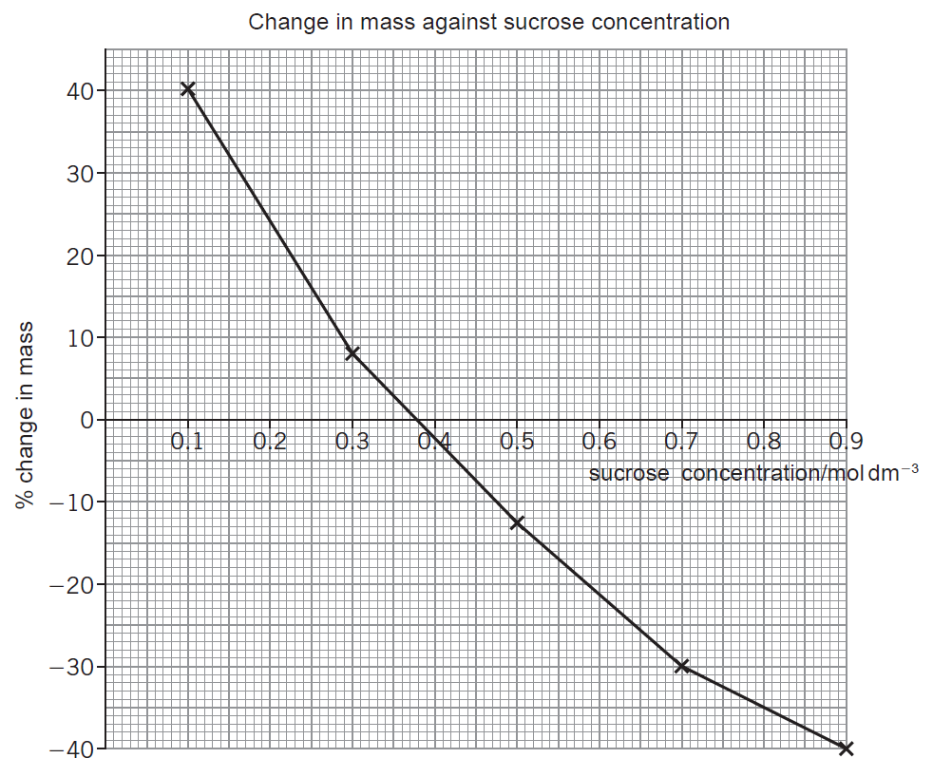.
- c Table 1: Strong correlation. Positive at the start. As light intensity increases, the increase in the rate of photosynthesis decreases (so the graph levels off).
Table 2: Strong correlation. Negative at the start. As time increases, the rate of the decrease of the concentration decreases (so the graph levels off).

