SERIAL DIULTION TECHNIQUE
- A serial dilution is a succession of step dilutions, each with the same dilution factor, where the diluted material of the previous step is used to make the subsequent dilution.
- For example, you might want to dilute a stock solution (the original solution) by half each time, or by a factor of 10 each time.
- It allows you to make a wider range of concentrations than a standard dilution, but still maintain a geometric progression.

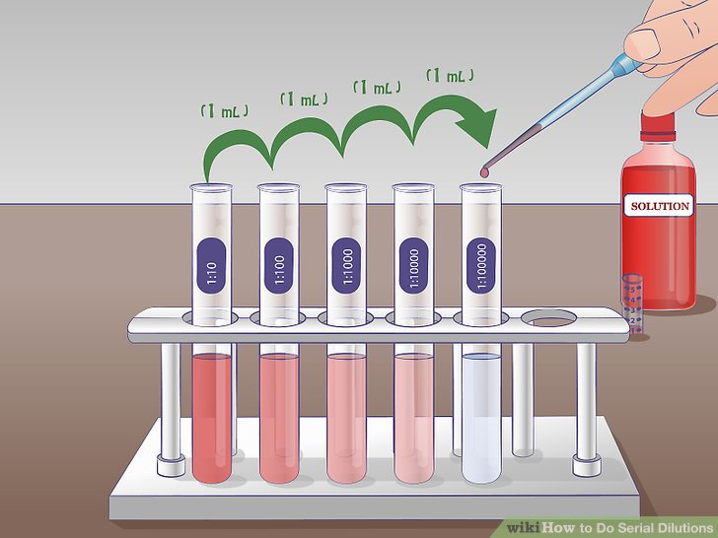

- In exam papers you are usually told what factor to dilute a solution by, then given a diagram to complete before doing your dilution.
- The following pages show three examples of serial dilution questions from recent papers.
- Complete the diagrams AND carry out the serial dilutions using the fake stock solutions provided. They have been coloured so you can see the dilution taking place. In each case you are diluting a stock solution with distilled water, W.
- NOTE: you will usually be asked to prepare more solution that you will actually use. Look carefully at the information already written by the first beakers.

Example 1
Stock solution: 4% glucose solution, G
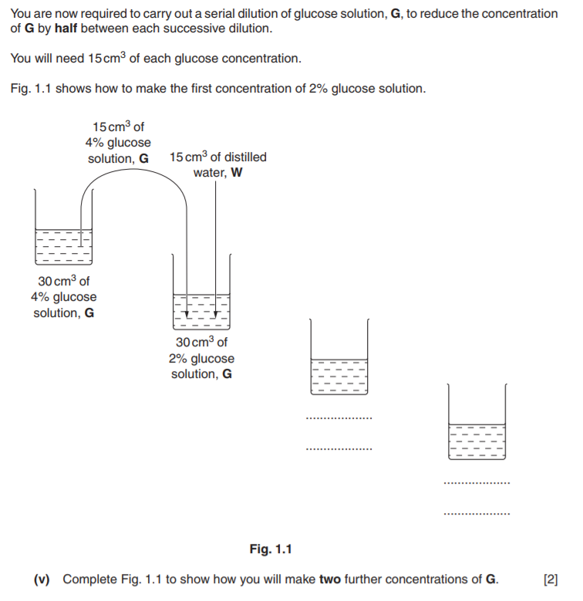

Example 2
Stock solution: 0.3% solution, X
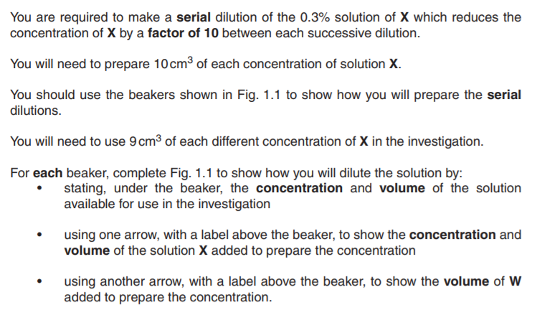
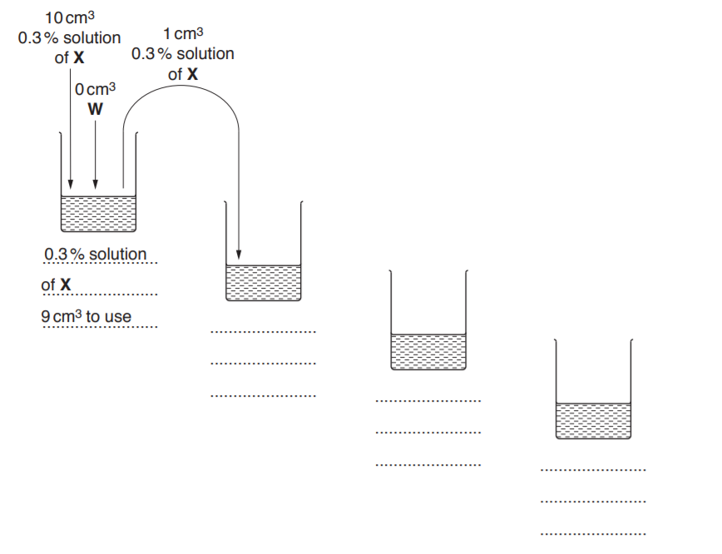
Fig 1.1
Example 3:
Stock solution: 10% sodium chloride solution, S

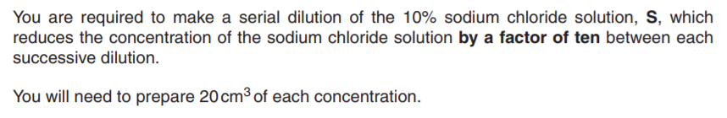
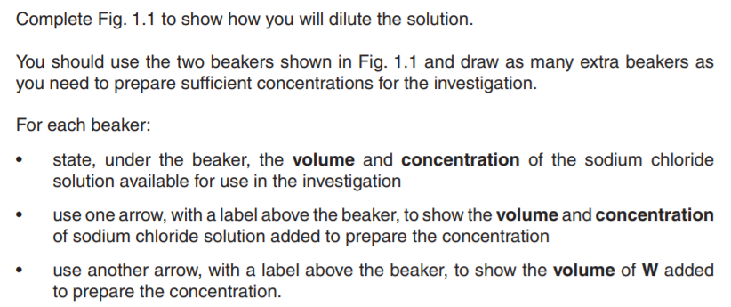
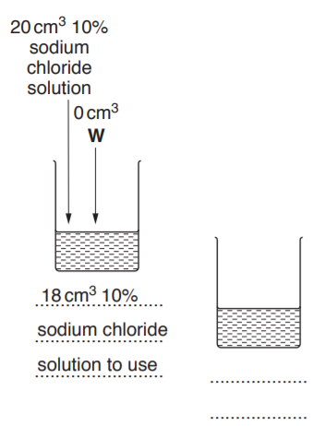

Fig 1.1

