AS Level Biology
Introduction to Biological Molecules: Monosaccharides

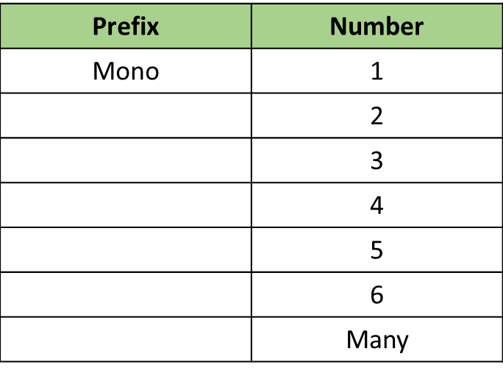
Know your prefixes

Definitions:
Monomer __________________________________________________________________
___________________________________________________________________________

Polymer ___________________________________________________________________
___________________________________________________________________________

Isomer ____________________________________________________________________
___________________________________________________________________________
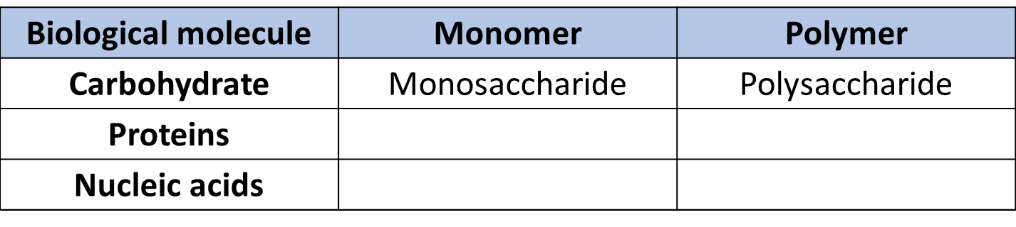

Monosaccharides | Disaccharide
Glucose + Glucose
Glucose + Fructose
Glucose + Galactose
Glucose Isomers
β - glucose
α - glucose

Condensation Reactions
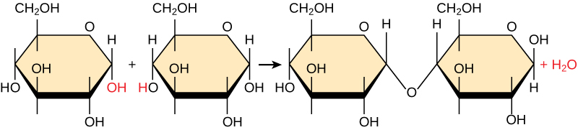

Hydrolysis Reactions
