Queen Elizabeth’s Grammar School
Year 6 – Science Transition Work

Name:

___________________________________________________

QEGS Science
Spreading Disease – ‘Glitter germs’ activity
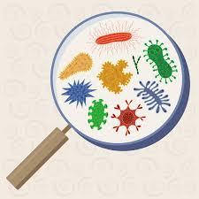
Germs are tiny living things that can cause disease. In science we call these tiny living things microbes or microorganisms.
There are three main types of microbes: Bacteria, viruses and fungi
Not all microbes are bad, in fact most of them are essential for our survival. For example, the bacteria living in our intestines help us to digest nutrients in the food we eat.
When bad microbes get into our body, they can multiply and make us ill. If we cough or sneeze, they can be spread around. Some microbes can survive on surfaces such as tables and door handles, and if someone else touches these surfaces it can cause the disease to spread to them too.
Effective handwashing helps stop the spread of microbes.
The following activity demonstrates why it is important to wash your hands regularly.
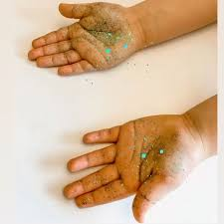
Equipment
- Glitter
- Hand lotion (or baby oil)
Procedure
- Ask someone to pour a small amount of hand lotion onto your palms. This represents the sweat on your hands. Spread it over your palms, but do not rub it in.
- Now ask them to sprinkle some glitter over your palms.
- Try some of the following activities (make sure you have an adult to supervise, so that you do not touch anything which could be damaged by the hand lotion or glitter):
  - Carry out some tasks which require you to touch things - open a door, write your name on a piece of paper. Ask someone else to then touch the surfaces you have touched.
  - Shake someone’s hand. Then ask that person to shake someone else’s hand.
- Observe carefully where the glitter has ended up.
- Try to remove the glitter from your hands using the following methods:
  - Wiping your hands with a dry tissue.
  - Rinsing your hands under cold water.
  - Washing your hands with soap and water.
Questions
- What happened when you touched different surfaces with your glitter hands?
- What happened when other people then touched surfaces which you had touched?
- What happened when you shook someone’s hand? What happened when they then shook another person’s hand?
- What did you find out when you tried to use the three different methods to remove the glitter?
- The glitter represents microbes on your hand. What has this experiment taught you about:
  - How microbes are spread?
  - The importance of washing your hands thoroughly?
Activity
Create a poster, leaflet, video or podcast aimed at primary school children, teaching them about the importance of washing their hands thoroughly.
Make sure you include information such as:
- What ‘germs’ are
- Why they are dangerous
- How they spread
- How we can stop the spread
Extension – Carry out some of your own research, using sources such as the NHS website. Include information such as:
- Examples of diseases caused by each type of microbe (bacteria, virus, fungi)
- The correct technique for thoroughly washing your hands

