Queen Elizabeth’s Grammar School
Year 6 - English Transition Work

Name:

___________________________________________________

Question
- Find out who Malala Yousafzai is.
- Read the quote below and think about what her hopes and dreams for her future are:
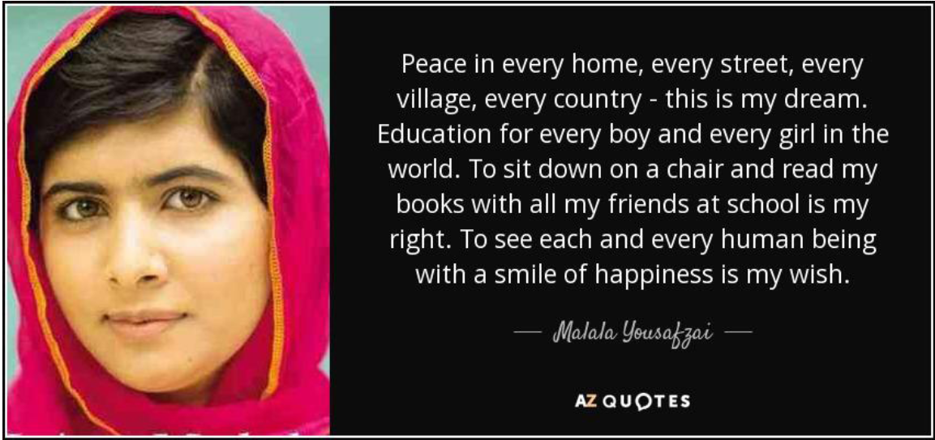
- Using the information you have researched, consider why this is her dream. What does Malala want to achieve in her life?

How do you think you can contribute towards Malala’s dream?

How could your time at QEGS help you to contribute to Malala’s dream?

Explore
Discuss with someone at home what you think your dreams are for the future. What do you hope QEGS will be like? Gather your ideas in the thought bubble below:
What can you do, whilst schools are closed, to prepare you to achieve these dreams at QEGS?

Fill in the Dreambow below, adding as many dreams for the future as you can.

Read the poem below, New Beginnings:
And so always keep on learning;
There’s always more to know.
It may sound strange, but you can always change.
It’s never too late to grow.

And so don’t let anybody
Try and sneer and hold you back.
Your history is not your future!
So don’t ever feel like that.

Because our town has a history
Of producing boys and girls
Who, from humble roots, Pull up their boots
And go on to change the world!

And so people just like you and me
Can do very special things!
Aim higher! Be high--‐flyers!
And be bold, unfold your wings!

And so gain an education;
Learn skills, gain facts and knowledge.
And then take the inspiration
Through to jobs, careers and college.

And so make the most of these days,
The school and these facilities.
Take off the brakes, be sure to make
The best of your abilities.

Respect yourself and others.
Have confidence --‐ it’s essential.
If you keep a burning urge to learn
You’ll reach your full potential.

And so do things that you’re proud of!
And let everybody see:
You’ve passed the test, you’ve done your best
To be the best that you can be!
Welcome to your new school!
Welcome to your future.
New beginnings here, and new rules.
New classrooms, new computers.

New timetables, new faces here.
New corridors, new signs.
But some things change, some stay the same
And some truths last all time.

You’ll take out what you put in.
You’ll reap just what you sew.
So face the tests and do your best,
Work hard, play hard and grow.

And play a full and active part
In school and its community.
Be pleased to say “I seized the day.”
“I used this opportunity.”

Remember that you’re different.
There’s no--‐one quite like you.
But make good friends, the one’s who’ll lend
A hand to get you through.

Remember – keep your head up.
Even if you fear you’ll drown.
Achieving is believing mixed
With never looking down.

And think about your future;
And find a hope, a dream.
Put action in your action plan
And build yourself a team.

Made of parents, made of teachers,
Made of family and friends.
From this position make a mission
For a trip that never ends.

To help you with the reading, watch the youtube video of Tony Walsh reading the poem:

https://www.youtube.com/watch?v=gMCZ0BM2Vrc

Answer the following questions about the poem:
- Why do you think that the poem is titled ‘New Beginnings’?

- How does the title of this poem link to you starting at QEGS in September?

- How does the poet feel about secondary school?

- How does this poem make you feel about starting secondary school? Why?

Create a storyboard below with some of the most interesting points from the poem:

Use the space below to plan ideas for your own poem about starting at QEGS in September:
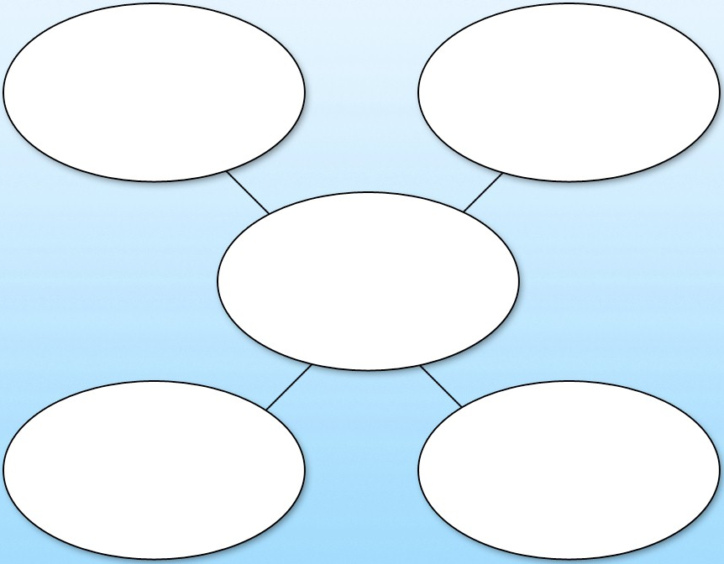
Can you challenge yourself to include the following techniques?
- Simile
- Metaphor
- Personification
- Alliteration
- Repetition
- Range of sentence openers
Write your poem and send it to:
rushton-plant@queenelizabeths.derbyshire.sch.uk

There will be recognition in September for the best ones.

