Reading List
A Level
Subject: Business and Economics

Core reading expectations of the A level course

Newspapers
Economist (student deal allows school subscription for £15 for the year)
Financial Times
Guardian
Independent
Times
Telegraph
The Week
Business Review

A level journals
Economics Review
Economics Today

Advanced reading

Introductory books for AS level
The Financial Times Guide to Business Start Up 2015 by Sara Williams
New Ideas from Dead Economists: An Introduction to Modern Economic Thought by Todd Buchholz
The Worldly Philosophers: The Lives, Times and Ideas of the great Economic Thinkers by Robert Heilbroner
Free Lunch: Easily Digestible Economics by David Smith
The Armchair Economist: Economics & Everyday Life by Steven E. Landsburg
The Return of Depression Economics by Paul Krugman
The Accidental Theorist: And Other Dispatches from the Dismal Science by Paul Krugman
The Undercover Economist by Tim Harford
The Undercover Economist Strikes Back: How to Run or Ruin an Economy by Tim Harford
The Logic of Life: Uncovering the New Economics of Everything: The Undercover Economist by Tim Harford
Freakonomics: A Rogue Economist Explores the Hidden Side of Everything by Steven D. Levitt and Stephen J. Dubner
Keynes: The Twentieth Century's Most Influential Economist by Peter Clarke
A level books
Losing Control: The Emerging Threats to Western Prosperity by Stephen D King
When the Money Runs Out: The End of Western Affluence by Stephen D. King
Civilization: The Six Killer Apps of Western Power by Niall Ferguson
The Ascent of Money: A Financial History of the World by Niall Ferguson
This Time Is Different: Eight Centuries of Financial Folly by Carmen M. Reinhart and Kenneth Rogoff
Paper Promises: Money, Debt and the New World Order by Philip Coggan
End This Depression Now! by Paul Krugman
The Conscience of a Liberal: Reclaiming America from The Right by Paul Krugman
The Price of Inequality by Joseph Stiglitz
Crisis Economics: A Crash Course in the Future of Finance by Nouriel Roubini
How Markets Fail by John Cassidy
Animal Spirits by George A. Akerlof and Robert J. Shiller
Capital in the Twenty-First Century by Thomas Piketty
A Modern guide to Macroeconomics: An Introduction to Competing Schools of Thought by Brian Snowdon, Howard Vane and Peter Wynarczyk
The Black Swan: The Impact of the Highly Improbable by Nassim Nicholas Taleb
Poor Economics: A radical rethinking of the way to fight global poverty by Abhijit Banerjee and Esther Duflo
The entrepreneurial state: Debunking Private vs Public Sector Myths by Marianna Mazzucato

Behavioural economics
Nudge: Improving Decisions About Health, Wealth and Happiness by Richard H Thaler and Cass R Sunstein
Misbehaving: The Making of Behavioral Economics by Richard H Thaler
The Signal and the Noise: The Art and Science of Prediction by Nate Silver
Thinking, Fast and Slow by Daniel Kahneman
Reports

Bank of England
Economist Special Reports
HM Treasury
IFS (especially the Green Budget)
Joseph Rowntree Foundation
Office of Budget Responsibility
UNDP Millennium Development Goals Report
World Bank
Department for Business Innovation and Skills
Confederation of British Industry

Websites

BBC Business
Economist
Financial Times
Guardian
HM Treasury
Institute of Fiscal Studies
New York Times
Office for National Statistics
Telegraph
Tutor2U
UNDP
World Bank

Podcasts

The Story of Economics http://www.bbc.co.uk/programmes/b00zfk8t
Michael Blastland lays out the history of economic ideas to understand why economics goes wrong and whether it can ever go entirely right.

Pop Up Economics http://www.bbc.co.uk/podcasts/series/thpop
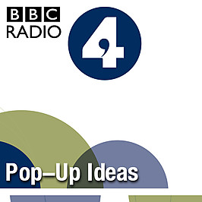
Tim Harford – in the company of Malcolm Gladwell, David Kilcullen and Gillian Tett – uses key ideas in anthropology and the social sciences to tell fascinating stories about how we - and the world – work.

Freakonomics http://itunes.apple.com/us/podcast/freakonomics-radio/id354668519

The Bottom Line with Evan Davis http://www.bbc.co.uk/podcasts/series/bottomline
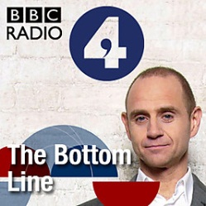
Insight into business from the people at the top. Evan Davis meets influential business leaders for a round table conversation about the issues that matter to their companies and their customers. The BBC produces two radio versions of this programme - one for the UK audience that can be heard on BBC Radio 4 on Thursday evenings at 20:30 GMT, and one for the international audience that can be heard on BBC World Service on Fridays at 22:06 GMT.

Analysis http://www.bbc.co.uk/podcasts/series/analysis
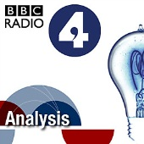
Analysis makes sense of the ideas that change the world. What made Islam political, whether the Government can make us go green, why we think the market in human organs is repugnant are just some of the subjects the series tackles. With thought-provoking and expert presenters, Analysis aims to make the world of policy and ideas both interesting and surprising. There are 26 episodes a year, in three series. Podcasts are available for a week after transmission while the programme is on air.

Reith Lectures http://www.bbc.co.uk/podcasts/series/reith
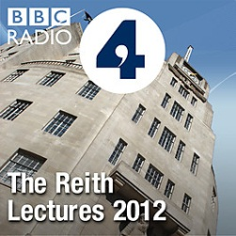
The economic historian Professor Niall Ferguson presents the 2012 BBC Reith Lectures, titled The Rule of Law and Its Enemies. Across four programmes he explores the role of man-made institutions on global economic growth and democracy, referencing the global economic crisis and financial regulation, as well as the Arab Spring. The first programme will be available to download on Tuesday, 19 June 2012.

Peter Day’s World of Business http://www.bbc.co.uk/programmes/p02nrwfk/episodes/downloads
Insights into the business world with Peter Day - featuring content from BBC Radio 4's In Business programme, and also Global Business from the BBC World Service.

TV/film:
Netflix
The Founder
Steve Jobs – Billion Dollar Hippie
The Social Network
Inside Bill’s Brain
American Factory
Fyre – The greatest festival that never happened
The Big Short
The Great Hack
Amazon Prime
Generation Start Up
Pepsi vs Coke
Jobs vs Gates
Starbucks Unfiltered
Facebook – Cracking the Code
Rich and Famous Fortunes

