Transition Pack
A Level Geography
2020
Name: _________________________________________
Deadline for completion September 2020

You might want to enter the RGS Young Geographer of the Year - Launches April 2020

PAPER 2
Paper 2 has two topics; 1) Globalisation and 2) Regeneration
GLOBALISATION
EQ1 – What are the causes of globalisation and why has it accelerated in recent decades?
Definitions Task: For each of the following key words find a definition:
Outsourcing
Economies of scale
Time-space compression
Shrinking world
International Monetary Fund
World Trade Organisation
Trading blocs
Tariff
Trade liberalisation
Subsidies
Foreign Direct Investment
Special Economic Zones
Interdependence
Transnational Corporations
Protectionism
Global hub
Outsourcing
Offshoring
Glocalisation
Gross Domestic Product
Containerisation
Task: Describing patterns
- Task: Annotate each of the maps to describe what the map shows.
- Link this back to globalisation. How does this make the world more integrated?
- Consider: Why is it significant in making places more interdependent? How could this make places more vulnerable?
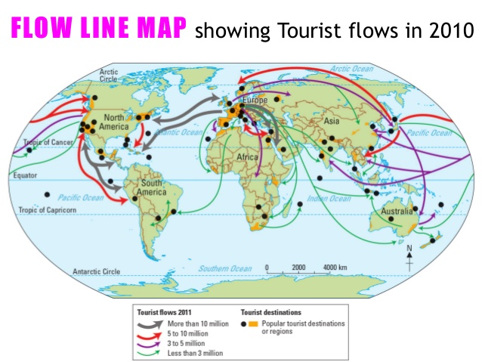

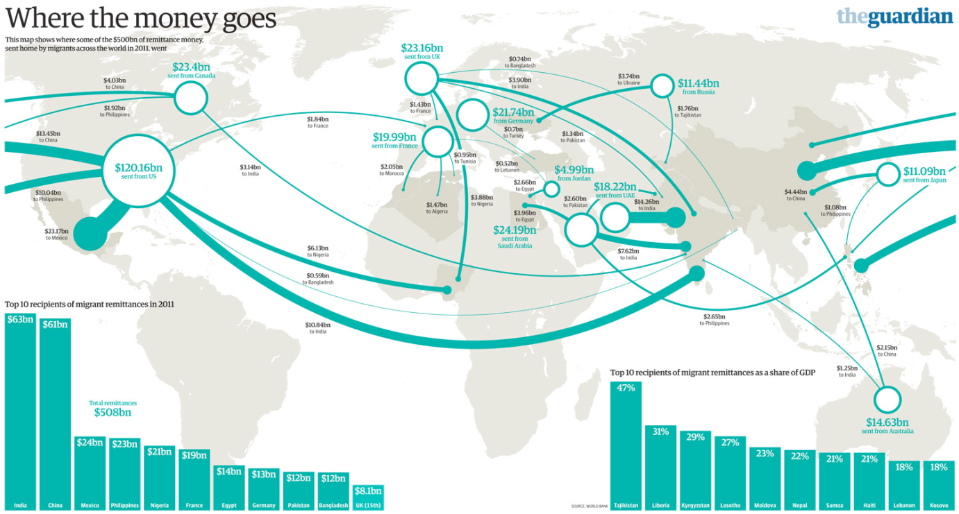

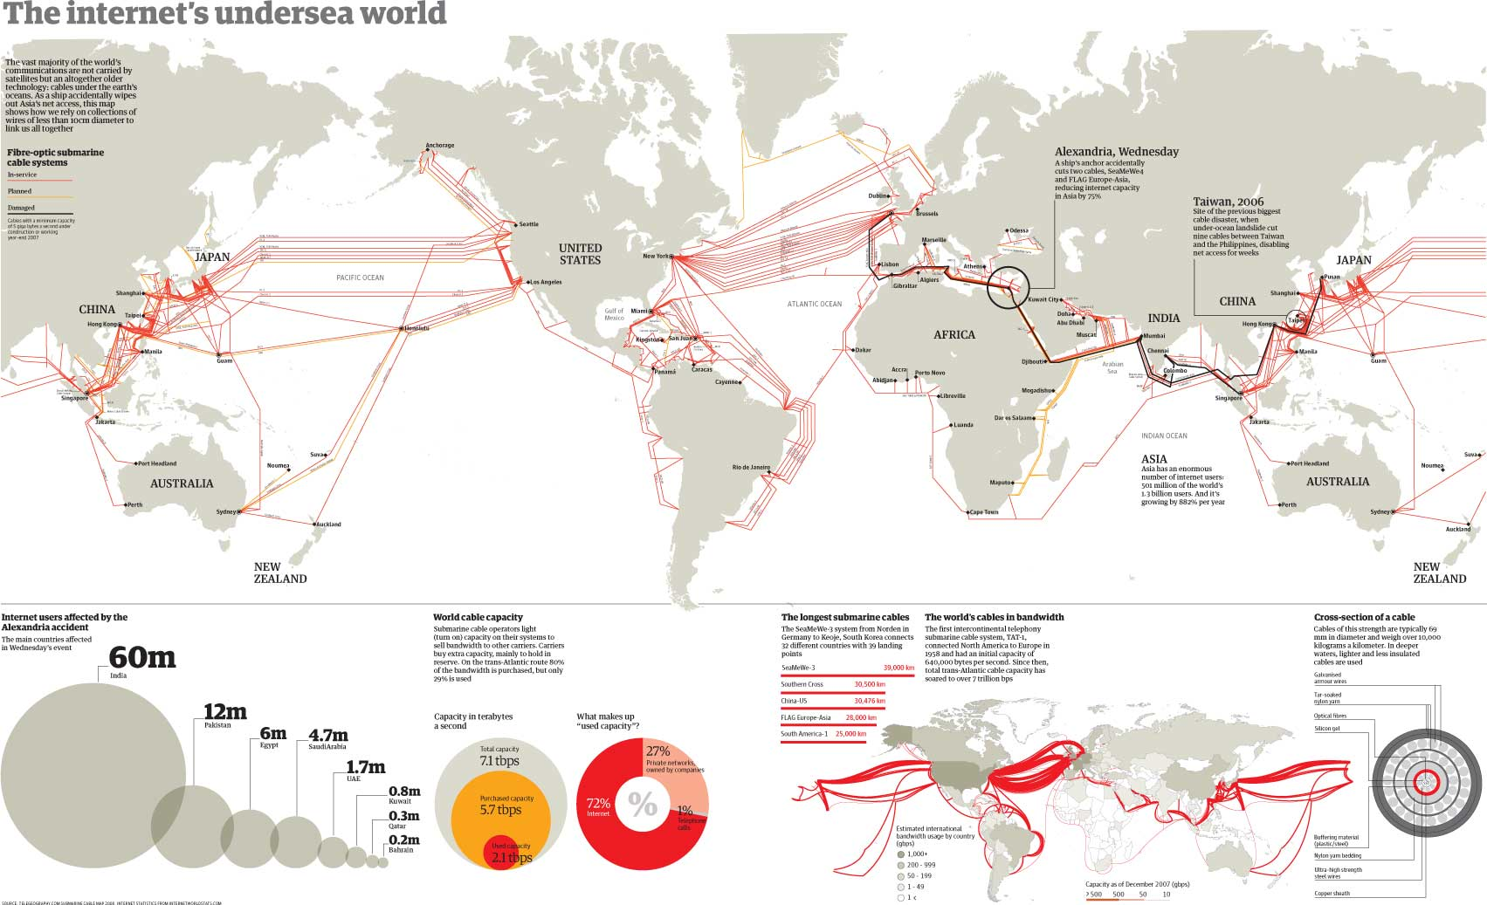

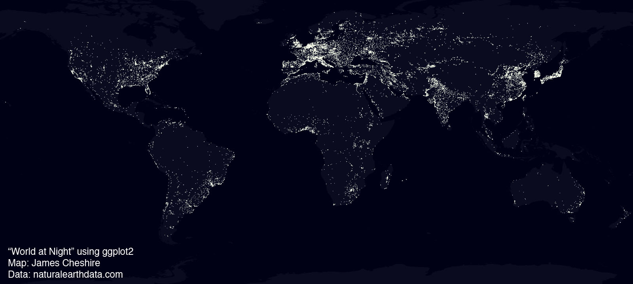

REGENERATION
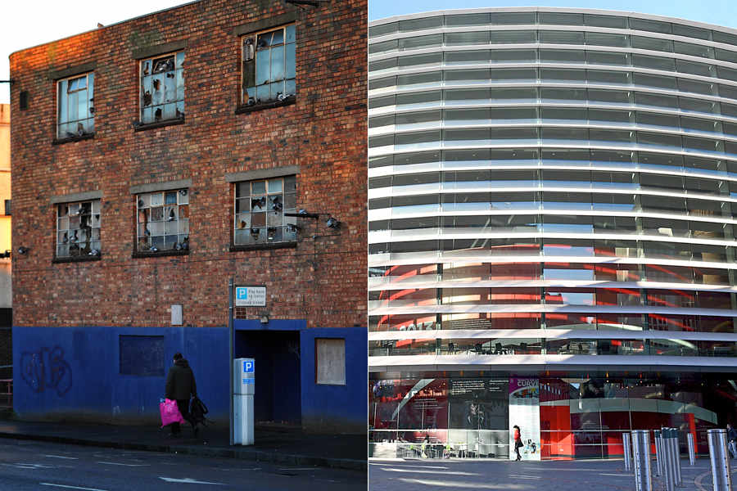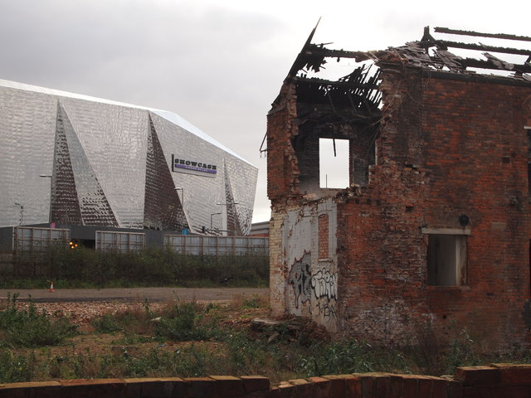
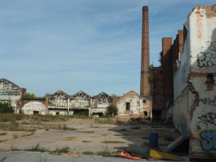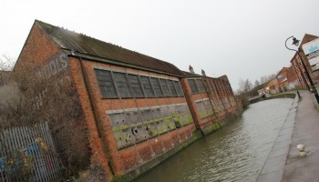
You will study four enquiry questions whilst exploring ‘Regenerating Places’ -
- How and why do places vary?
- Why might regeneration be needed?
- How is regeneration managed?
- How successful is regeneration?

HOW AND WHY DO PLACES VARY?
In this first enquiry question, you are expected to undertake an in-depth study of the local place in which you live or study (which will be Derby) and one contrasting place (Liverpool).
Your task is to complete secondary research on your local place, Derby, to focus on enquiry questions 2 and 3.
ENQUIRY QUESTION 2: WHY MIGHT REGENERATION BE NEEDED?
Why did Derby need to be regenerated?
Use the internet, local libraries, the Records Office and your own knowledge to find out why Derby needed to be regenerated. You need to consider a wide range of questions and find out if they applied or apply to Derby, such as;
- Has the city experienced deindustrialisation?
- Have industries closed down and for what reasons?
- What was/is the level of unemployment?
- Are there skills shortages?
- Has the area experienced outward migration?
- What has happened to property prices?
- Does the area suffer from social deprivation (health, education, crime and access to services)?
- Is there any evidence of sink estates, commuter villages or declining rural settlements?
- Are local communities engaged in the area (consider election turnout and local community groups)?
- What is the ethnic mix/make-up of the area?
- What is the population structure of the area?
- Are there many new residents (students, in-migrants)?
- Is there evidence of conflict between different groups within communities?

ENQUIRY QUESTION3: HOW IS REGENERATION MANAGED?
Has national government made any policy decisions that have had an impact on Derby’s regeneration? i.e.:
- Have they improved transport infrastructure?
- Have they passed new planning laws?
- Have they set house building targets?
- Have they made decisions about international migration?
Has local government taken decisions to make the area look more attractive to inward investors?
- Have they created science parks, industrial estates to attract new firms to the area?
- Are local interest groups (Chamber of Commerce, preservation societies) involved in the key decision-making process in the area?
- Have they been involved in any leisure and tourism, retail or sport strategies to regenerate the area?
- Have they encouraged rural diversification?
Has rebranding taken place to change the public’s perception of the area?
- Has the area experienced any urban or rural rebranding?
- Has the urban area been rebranded around industry, culture, heritage or sport?
- Has the rural area been rebranded around specialist products, outdoor pursuits, heritage or film?

REGENERATING PLACES GLOSSARY
Complete the glossary, remembering that the terms are all related to regenerating places, in either urban or rural areas.
- Area based incentives
- Cold spots
- Community groups
- Commuter villages
- Deindustrialisation
- Demographic changes
- Depopulation
- Deprivation
- Environmental inequality
- Flagship regeneration projects
- Gated communities
- Gentrification
- Glasgow effect
- High Speed Two (HS2)
- Index of Multiple Deprivation (IMD)
- Indicators of success
- Legacy
- Levels of engagement
- Lived experience
- Local Enterprise Partnership (LEP)
- Marginalisation
- Not In My Back Yard (NIMBY) groups
- Postcode lottery
- Rebranding
- Regeneration
- Regeneration strategies
- Re-imaging
- Re-inventor cities
- Replicator cities
- Rural – urban continuum
- Rural proofing
- Service inequality
- Sink estate
- Social inequality
- Social polarisation
- Social segregation
- Spiral of decline / De- multiplier effect
- Studentification

Paper 1
Paper 1 has two topics; 1) Tectonic Processes and Hazards and 2) Landscape Systems, Processes and Change – Coastal landscape and change
Tectonic Processes and Hazards.
Enquiry Questions:
1. Why are some locations more at risk from tectonic hazards?
2. Why do some tectonic hazards develop into disasters?
3. How successful is the management of tectonic hazards and disasters?

This topic develops your knowledge from GCSE. Use the information below, your own knowledge AND additional research to complete the tasks below.

Plate Boundaries

1. For each plate boundary identify the different tectonic hazards to be found and the key features.
Plate boundary | Earthquakes and/or volcanoes | Key features (direction of plate margin, type of plate,
Destructive
Constructive
Collision
Transform (Conservative)

2 - Explain the cause of earthquakes at constructive plate margins (4)
………………………………………………………………………………………………………………………………………………………………………………………………………………………………………………………………………………………………………………………………………………………………………………………………………………………………………………………………………………………………………………………………………………………………………………………………………………………………………………………………………………………………………………………………………………………………………………………………………………………………………………………………………………………………………………………………………………………………………………………………………………………………………………………………………………………………………………………………………………………………………………………………………………………………………………………………………………………………………………………………………………………………………………………………………………………………………………………………………………………………………………………………………………………………………………………………………………………………………………………………

3 - Explain the cause of volcanoes at destructive plate margins (4)
………………………………………………………………………………………………………………………………………………………………………………………………………………………………………………………………………………………………………………………………………………………………………………………………………………………………………………………………………………………………………………………………………………………………………………………………………………………………………………………………………………………………………………………………………………………………………………………………………………………………………………………………………………………………………………………………………………………………………………………………………………………………………………………………………………………………………………………………………………………………………………………………………………………………………………………………………………………………………………………………………………………………………………………………………………………………………………………………………………………………………………………………………………………………………………………………………………………………………………………………

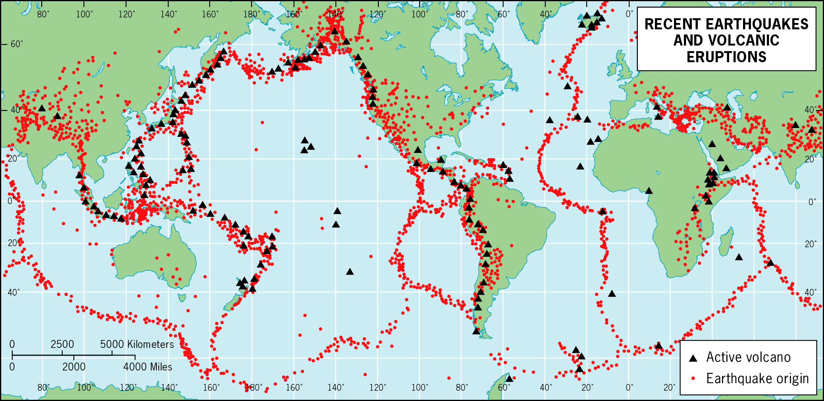
4. Explain why earthquakes and volcanoes are often located in similar locations (6)
……………………………………………………………………………………………………………………………………………………………………………………………………………………………………………………………….………………………………………………………………………………………………………………………………………………………………………………………………………………………………………………………………………………………………………………………………………………………………………………………………………………………………
……………………………………………………………………………………………………………………………………………………………………………………………………………………………………………………………….………………………………………………………………………………………………………………………………………………………………………………………………………………………………………………………………………………………………………………………………………………………………………………………………………………………………
……………………………………………………………………………………………………………………………………………………………………………………………………………………………………………………………….………………………………………………………………………………………………………………………………………………………………………………………………………………………………………………………………………………………………………………………………………………………………………………………………………………………………

5 - Case Study – Research

Complete research into one of the following hazards and produce a comprehensive case study with photographs and maps to support your research:

- Volcanic Eruption – Eyjafjallajokull, Iceland 2011 & Monserrat 1995.
- Earthquake – Christchurch, New Zealand 2010 and 2016 & Haiti 2010.
- Asian Tsunami 2004

For either hazard identify the cause, impacts (Social, Economic and Environmental) and Management of the hazard.

Landscape Systems, Processes and Change – Coastal landscape and change
Enquiry Questions:
1: Why are coastal landscapes different and what processes cause these differences?
2: How do characteristic coastal landforms contribute to coastal landscapes?
3: How do coastal erosion and sea level change alter the physical characteristics of coastlines and increase risks?
4: How can coastlines be managed to meet the needs of all players?

This topic also develops your knowledge from GCSE. Use the information below, your own knowledge AND additional research to complete the tasks below.

Coastal landscapes
The Jurassic Coastline in Dorset is one of the most famous stretches of coastline in terms of landforms and features.
6 - Your task is to research this stretch of coastline to create a case study. You will need to include photos and annotated maps to identify the different features along this stretch of coastline and start to explain how and why the different landforms are created.

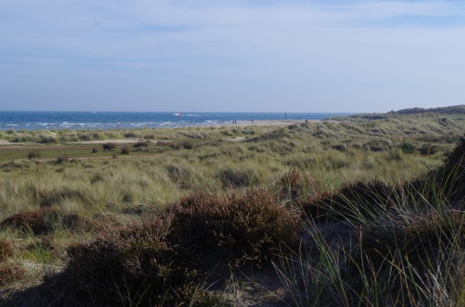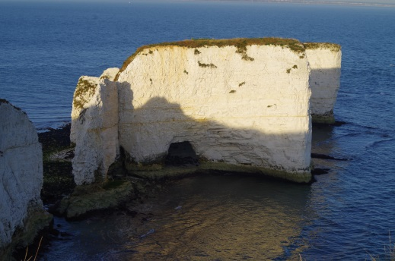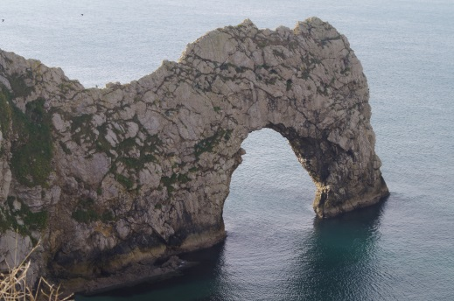

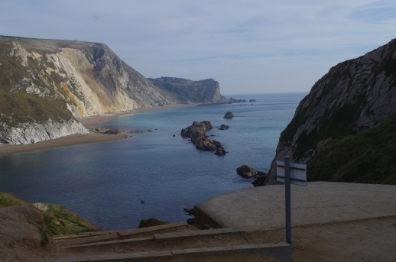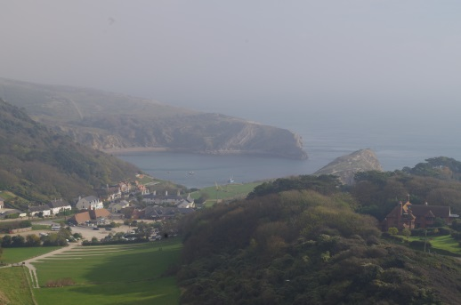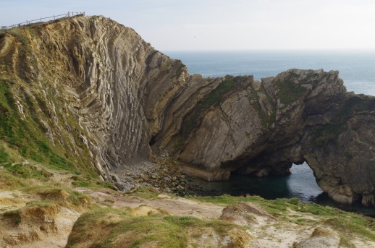

7 - Explain the relationship between geology and coastal form along the Dorset Coastline (6 marks)
………………………………………………………………………………………………………………………………………………………………………………………………………………………………………………………………………………………………………………………………………………………………………………………………………………………………………………………………………………………………………………………………………………………………………………………………………………………………………………………………………………………………………………………………………………………………………………………………………………………………………………………………………………………………………………………………………………………………………………………………………………………………………………………………………………………………………………………………………………………………………………………………………………………………………………………………………………………………………………………………………………………………………………………………………………………

WIDER READING
Using the next page to find your wider reading it can be books, news sites, magazines, podcasts, tv, films or websites.

Wider reading log
Name of article | Links to the course e.g. tectonics, water | 5 – 10 key points from the article

ONCE A GEOGRAPHER, ALWAYS A GEOGRAPHER!
The geography department would love for you to continue to stay cognitively engaged over the coming weeks and months, despite the cancellation of this year’s exams. The following are suggestions, they are not compulsory, but we would love for you to engage in any that you find interesting.
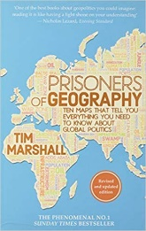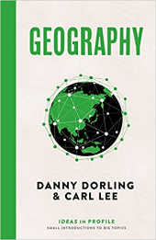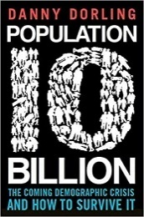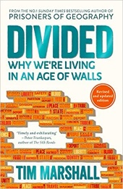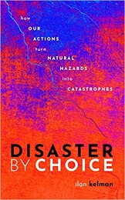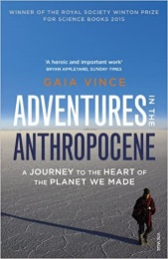

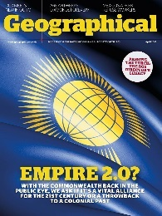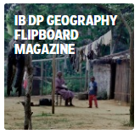

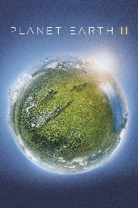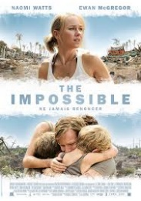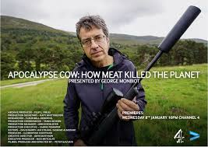

 | Overheard – National Geographic Podcast  Science Weekly – The Guardian Podcast  Ask the geographer Podcasts  The Development Podcast – World Bank  The World Economic Forum Podcasts | Planet Money – The economy explained  RGS Online Lectures  BBC Costing the Earth  BBC The Documentary Podcast  Living Planet Podcast

 | World economic forum videos  Royal Geographical Society Youtube  iPlayer Science and Nature Playlist  iPlayer Climate Change Playlist  BBC Earth | iPlayer Earth from Space  iPlayer Stacey Dooley on BBC Three  iPlayer Race Across the World  iPlayer Africa with Ade Adepitan  iPlayer Fashion Conscious

