ONCE A GEOGRAPHER, ALWAYS A GEOGRAPHER!
The geography department would love for you to continue to stay cognitively engaged over the coming weeks and months, despite the cancellation of this year’s exams. The following are suggestions, they are not compulsory, but we would love for you to engage in any that you find interesting.
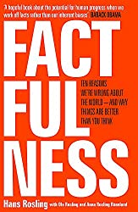
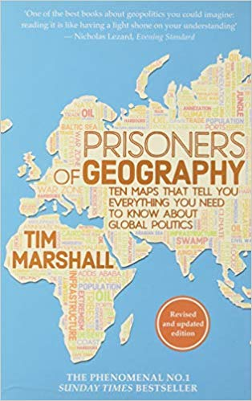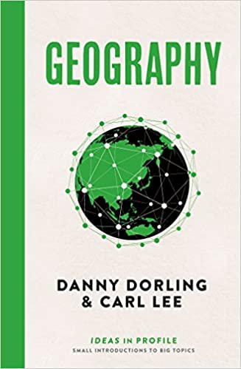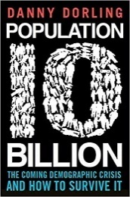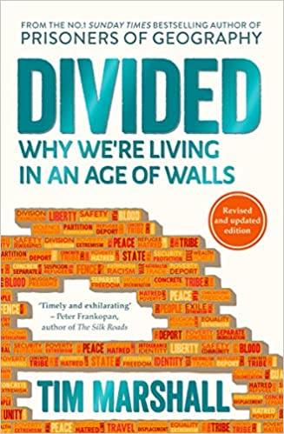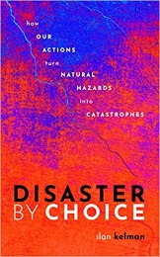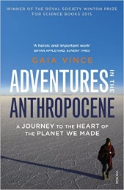

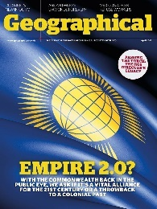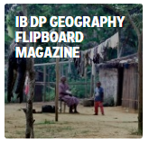

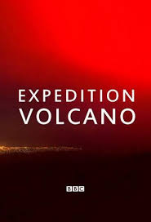
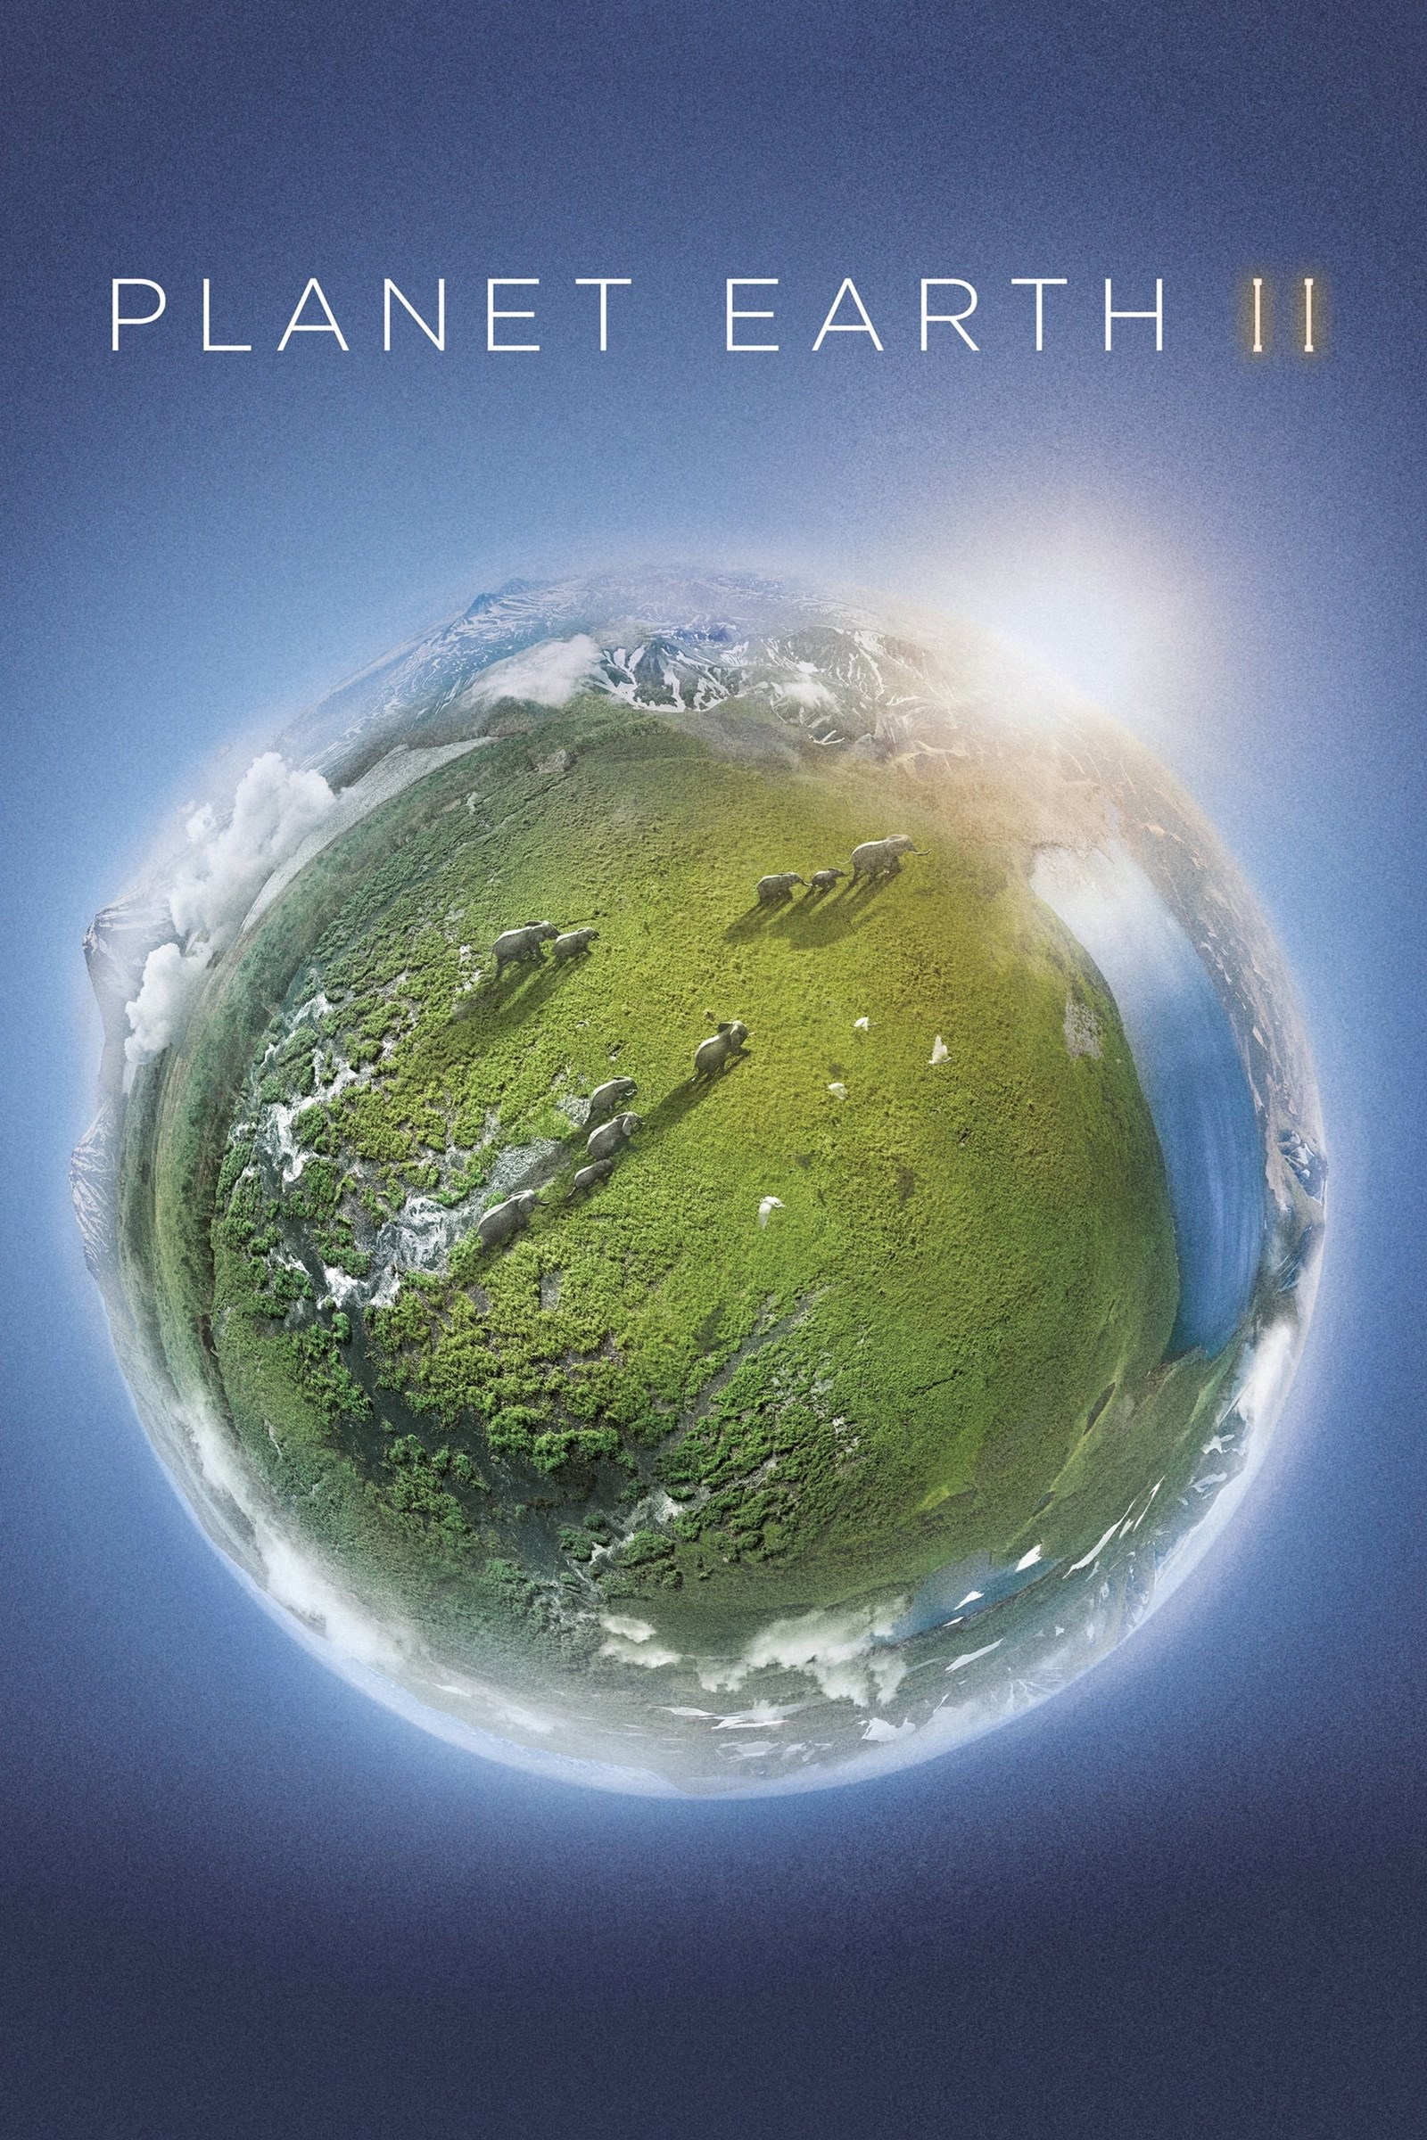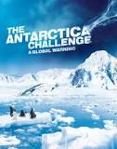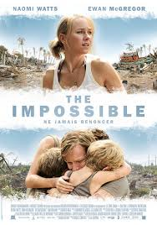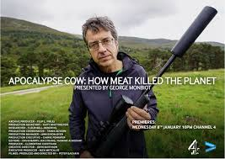

 | Overheard – National Geographic Podcast  Science Weekly – The Guardian Podcast  Ask the geographer Podcasts  The Development Podcast – World Bank  The World Economic Forum Podcasts | Planet Money – The economy explained  RGS Online Lectures  BBC Costing the Earth  BBC The Documentary Podcast  Living Planet Podcast

 | World economic forum videos  Royal Geographical Society Youtube  iPlayer Science and Nature Playlist  iPlayer Climate Change Playlist  BBC Earth | iPlayer Earth from Space  iPlayer Stacey Dooley on BBC Three  iPlayer Race Across the World  iPlayer Africa with Ade Adepitan  iPlayer Fashion Conscious

You might want to enter the RGS Young Geographer of the Year - Launches April 2020
If you would like to share what you’ve found interesting, we’d love for you to produce a piece that we could share with other students.

