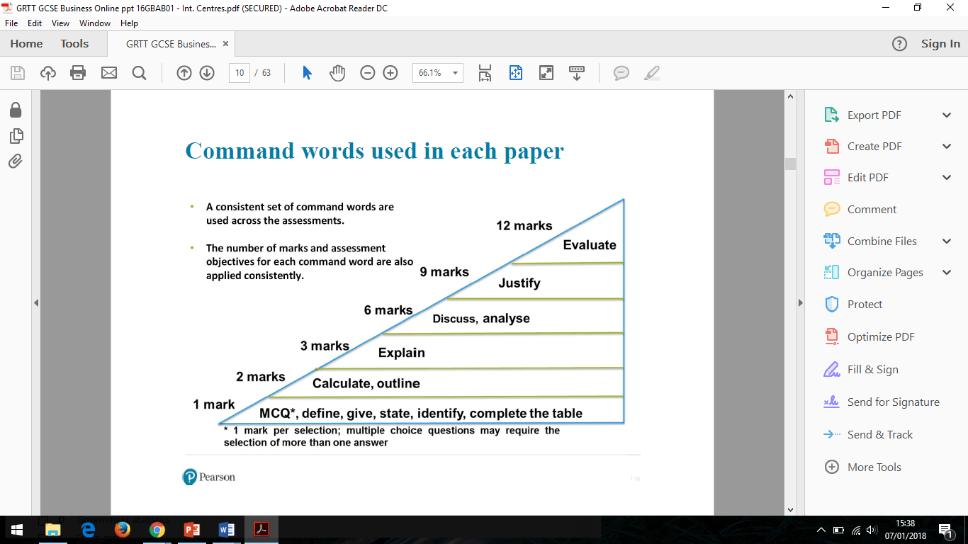

**WABOLL**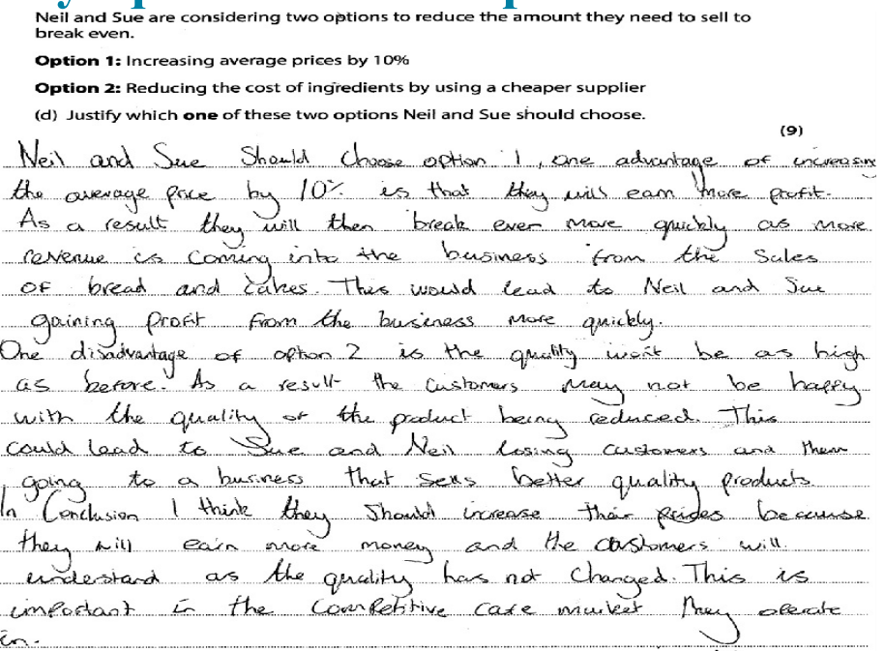

In this example the student has explained their reasons **FOR** Option 1, but has then argued the **DISADVANTAGES** for Option 2, which isn’t balanced.

**Choose either :**

Advantages Option1 and Advantage Option 2, Conclusion

**OR**

Advantage Option 1 and Disadvantages Option 1, Conclusion

**OR**

Advantage Option 2 and Disadvantages Option 2, Conclusion

**9 Mark Question**

**Justify**

**(AO2, AO3a and AO3b)**

**Section B and C – one justify question in each section**

This question will always involve a choice between 2 options and will usually look like this:

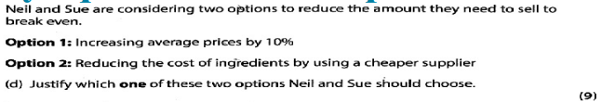

**OR**

Justify **WHETHER OR NOT** Neil and Sue should reduce prices

**Justify choice:** I would choose option …. because…. and this means that…. which results in…

**Counterbalance:** However….*Disadvantage of the same option or argument for choosing the other option*:

**Conclusion:** So Ultimately…

**There needs to be 5 interconnected points in your answer and you also need to include context** (*context could include competitor name, product name, location, price, type of business it is, but* ***can’t*** *be anything given in question)*

**WAGOLL**

**Assessment Objectives**

|  |  |  |
| --- | --- | --- |
| AO | Skill Tested | % on Paper |
| AO1a | Recall | 15% |
| AO1b | Understanding | 20% |
| AO2 | Context / Calculate | 35% |
| AO3a | Analysis | 20% |
| AO3b | Evaluation | 10% |

**Business Studies**

**Exam Technique Mat (GCSE)**

***9 Mark Question***

**\*\*Keep looking back at the question when answering\*\***



**Possible connectives** This means… as a result…therefore…consequently…. the impact of this… this leads to…. moreover… furthermore… also…. because…thus… so…however…ultimately…. In comparison…