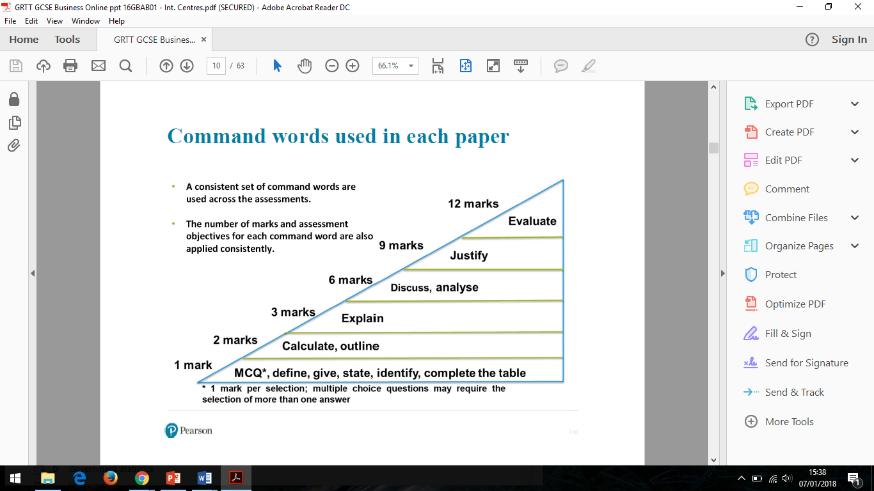

**6 Mark Question**

**Analyse**

**(AO2 and AO3a)**

**Section B – context required**

**There will be 2 of these in each paper**

Analyse an/the impact/ advantage etc

You can either discuss ONE or TWO impacts/benefits/drawbacks - no balance needed

There needs to be 5 interconnect points throughout the ONE or TWO impact/benefit/drawbacks

**WAGOLL**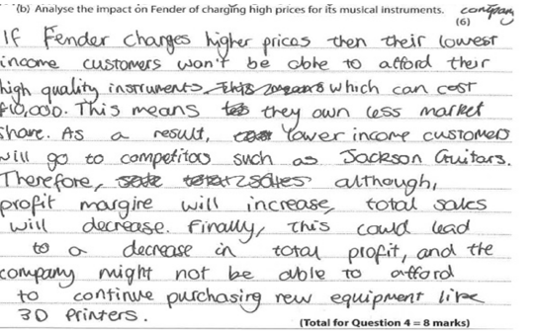

*(context could include competitor name, product name, location but* ***can’t*** *be anything given in question)*

**6 Mark Question**

**Discuss**

**(AO1b and AO3a)**

**Section A – no context required**

**There will be 1 of these in each paper**

Discuss what/ the likely impact/benefit/drawback etc

You can either discuss ONE or TWO impacts/benefits/drawbacks - no balance needed

There needs to be 5 interconnect points throughout the ONE or TWO impact/benefit/drawbacks

**WAGOLL**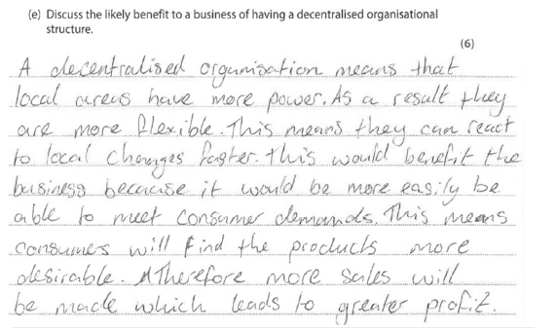

**Assessment Objectives**

|  |  |  |
| --- | --- | --- |
| AO | Skill Tested | % on Paper |
| AO1a | Recall | 15% |
| AO1b | Understanding | 20% |
| AO2 | Context / Calculate | 35% |
| AO3a | Analysis | 20% |
| AO3b | Evaluation | 10% |

**Business Studies**

**Exam Technique Mat (GCSE)**

***6 Mark Questions***

**\*\*Keep looking back at the question when answering\*\***



**Possible connectives** This means… as a result…therefore…consequently…. the impact of this… this leads to…. moreover… furthermore… also…. because…thus… so…