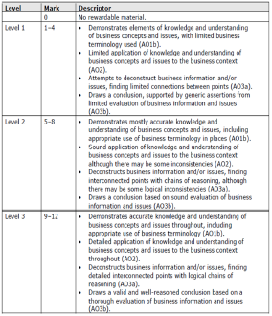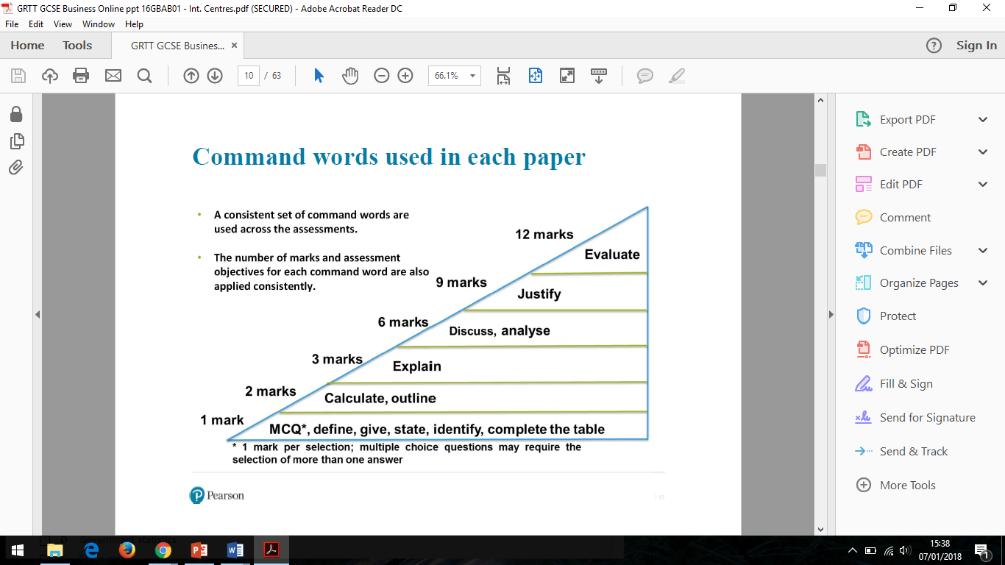

**Evaluate**

**(AO1b, AO2, AO3a and AO3b)**

**Section C – one evaluate question at end of each paper**

This is an extended writing question designed to test your understanding, application, analysis and evaluation. You should use all knowledge you have learnt throughout your Business GCSE.

**Your answer should follow the structure below:**

**Point 1 – with interlinked sentences.**

*One reason is… this is because… therefore…*

**Point 2 – with interlinked sentences**

*Another reason is… this leads to… this means…*

**Conclusion –** *In conclusion I believe… However, this depends on…*

**Mark Scheme**

You will be awarded a level of best fit and then a mark will be allocated within that level

**Examples**

**Assessment Objectives**

|  |  |  |
| --- | --- | --- |
| AO | Skill Tested | % on Paper |
| AO1a | Recall | 15% |
| AO1b | Understanding | 20% |
| AO2 | Context / Calculate | 35% |
| AO3a | Analysis | 20% |
| AO3b | Evaluation | 10% |

**Business Studies**

**Exam Technique Mat (GCSE)**

***12 Mark Question***

**\*\*Keep looking back at the question when answering\*\***



You need to evaluate **external and internal influences** throughout your answer

*What factors will influence the decision? What will it depend on? How competitive is the market? What are the current trends? Are there any cost pressures mentioned? Is the state of the economy important? Are there any ethical issues?*

**Context** is needed from the case study throughout your answer, one piece of context will not be enough.

There needs to be **5 interconnected points** in your answer for Level 3

**Possible connectives** This means… as a result…therefore…consequently…. the impact of this… this leads to…. moreover… furthermore… also…. because…thus… so…however…ultimately…. In comparison…