Breana Brill, Contributor
Professional Writing junior at Michigan State. Writer, social media addict, lover of puppies, coffee, traveling and brunch food.

A Letter To My 16-Year-Old Self

Thank you for being so strong for us.
07/21/2016 04:43 pm ET | Updated Jul 22, 2016
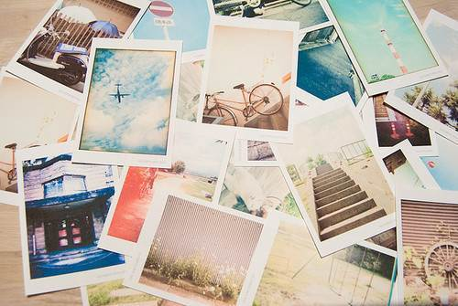
HTTPS://IHEARTTHEMANINTHEMOON.FILES.WORDPRESS.COM/2010/08/I-SPY.JPG

To My 16-Year-Old Self:
The moment you started high school a little over a year ago, people flooded you with warnings on how fast these years would fly. You always gave them the same classic “grin and nod” to show that you were listening, but it still hasn’t sunk in. Behind their back, you kind of shrugged your shoulders because you actually wanted these years to fly by.
You’re a sophomore in high school and sometimes present day me wishes I could go back and shake you. You sleepwalk through the school days and party away the weekends with people you don’t really care about.
Don’t get me wrong, some of your best memories will come from those weekends, the kind of memories that make your stomach hurt from laughing while relieving them with your then best friend, but you tend to forget how to balance your time. Don’t worry, it’s something you’ll learn in a few years because, like most 16-year-olds, you do not have your priorities straight. To be honest, it’s probably because you don’t really know what your priorities actually are.
These years will slip through your fingers, and the moment you realize it will be our senior year, but by then it’ll be too late to catch it. And that’s okay. It was a key lesson we learned in high school; it helped us learn the importance of living in the moment and loving every second of it without being too caught up in our future.
As I look back at those years as learning experiences, I thank you for being so strong for us because those years shaped us into who we are (and aren’t) today. You feel like time is frozen. The way you talk about the future with your best friend is like you two are going to be teens forever and your 20s are so far off in the future it seems untouchable. Unfortunately, reality slapped us in the face with the big 2-0 this year and it was kind of shocking because, between you and me, I still feel like 16-year-old us sometimes.
You are so innocent. Looking back at some of the things you went through hurts me because you just didn’t know or understand. But at the same time, I love that about you. Some people roll their eyes at that type of innocence and invincibility we all felt at your age, but I look back and wish you could have felt it a little longer. Sometimes I even wish I could go back to it completely. The hopeful view you have for life is so beautiful because it’s based off of pure curiosity, untouched by how cruel the world and people in it could be.
I can still see your wide eyes, so thirsty for knowledge and adventure. This is the year you really start developing your writing and the ability to fearlessly speak your mind, a trait that I am so thankful for today. You’ve never been scared to share your opinion, whether or not you knew people would agree with you. Four years later and that fearlessness has given us more opportunities than you could ever imagine.
I want you to know that the anxiety you feel towards life is normal, but the way you deal with it is not healthy. It’s easy to feel like you’re the only person in the world who is sad or scared when you bottle up your emotions, but trust me when I say the friends and family you have in your life right now would do anything for you and some of them might be feeling the same way. They would drop what they were doing in a heartbeat to listen and cry with you, but you have to tear down the wall you build around yourself and let them in. It’s okay to be vulnerable. It’s scary, that’s for sure, but I promise it will help with all the emotions you’ve been building up for awhile.
The last thing I want to tell you is to stop rushing these last three years you have at home. I can tell you that college is amazing, but it will come on it’s own. Spend the time you have with your best friends because even though you want to stay in touch after college, life tends to get in the way. Thank the teachers who actually cared about you and did more than their job asked for, because they will have a bigger influence on your life than you realize at the time.
Give your dog the biggest hug and kiss you could possibly imagine because the next four years is going to be the change you never wanted to happen. And hug your family, because in two years you’re going to move a few hundred miles away from home and not have the ability to do so when we want to.
Know that you are loved and the future you’re working towards right now is brighter than you can imagine. I can’t wait for you to sit back in four years as a 20-year-old and smile so big because you know how far we’ve come in so little time.
Much love and luck to you for these next few years,
Your 20-Year-Old Self
P.S. Please, for the love of God, stop posting Facebook statuses ― trust me, saving you from embarrassment in a few years.

