4.1.1 Globalisation

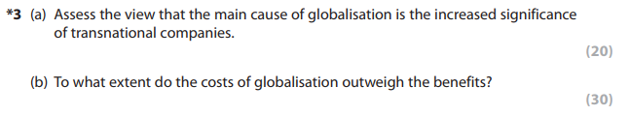
Jun 12
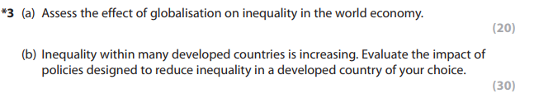
Jun 13

4.1.2 Specialisation and trade

4.1.3 Pattern of trade

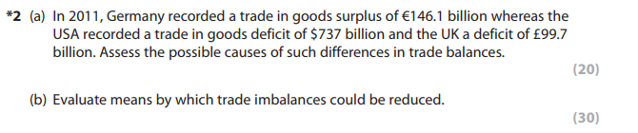
Jun 13
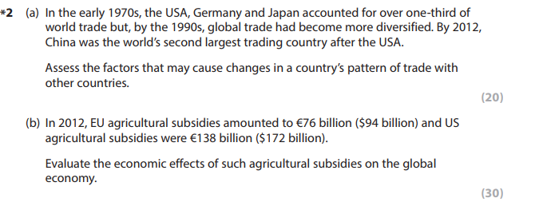
Jun 14
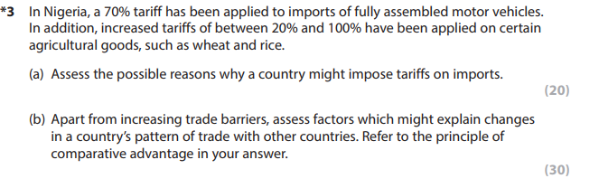
Jun 16

4.1.4 Terms of trade

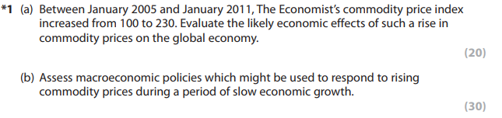
Jun 12

4.1.5 Trading blocs and the World Trade Organisation (WTO)
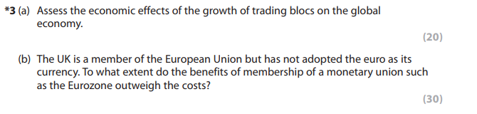
Jun 11
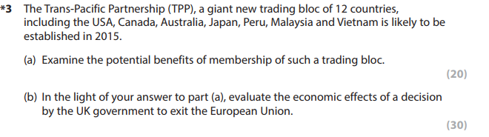
Jun 15

4.1.6 Restrictions on free trade
Jun 16

4.1.7 Balance of payments
Jun 13

4.1.8 Exchange rates

4.1.9 International competitiveness

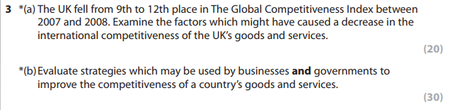
Jun 10
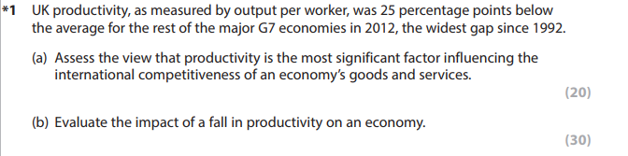
Jun 16

4.2.1 Absolute and relative poverty
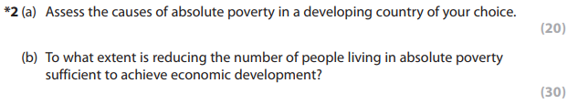
Jun 11

4.2.2 Inequality

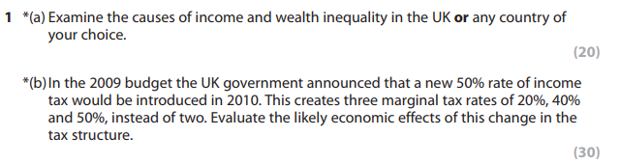
Jun 10
Jun 13
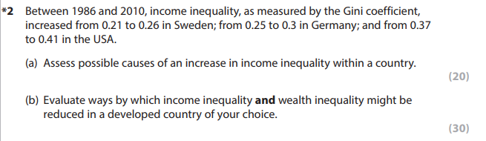
Jun 16

4.3.1 Measures of development

4.3.2 Factors influencing growth and development
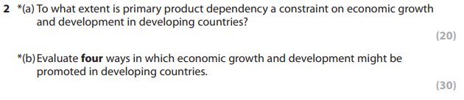
Jun 10
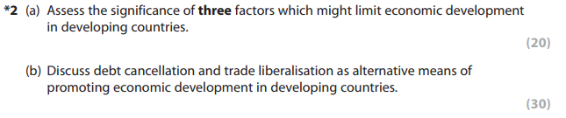
Jun 12
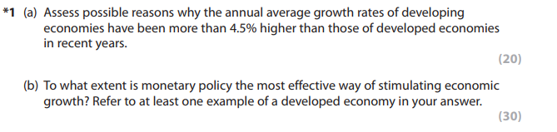
Jun 13
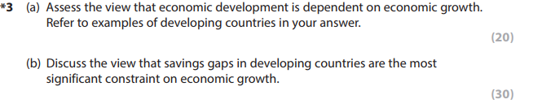
Jun 14
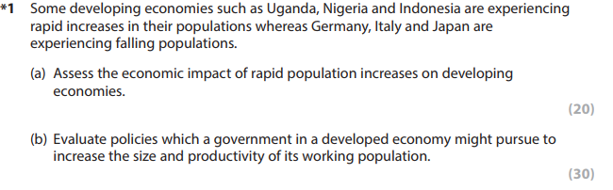
Jun 15

4.3.3 Strategies influencing growth and development

Jun 10
Jun 11
Jun 12
Jun 14

4.4.1 Role of financial markets

4.4.2 Market failure in the financial sector

4.4.3 Role of central banks
Jun 13

4.5.1 Public expenditure
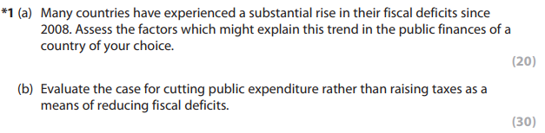
Jun 11
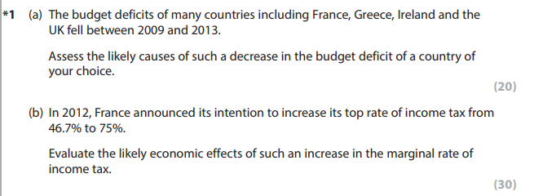
Jun 14
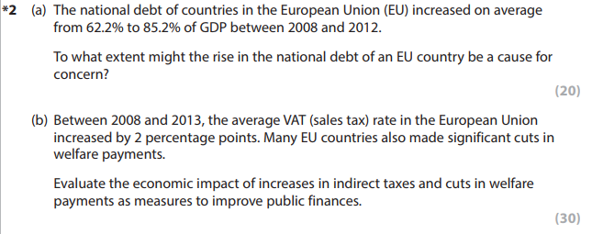
Jun 15

4.5.2 Taxation
Jun 10
Jun 11
Jun 14

4.5.3 Public sector finances
Jun 11
Jun 14
Jun 15

4.5.4 Macroeconomic policies in a global context
Jun 12
Jun 13
Jun 14
Jun 15

