Reading List
A Level
Subject: Business and Economics

Core reading expectations of the A level course

Newspapers
Economist (student deal allows school subscription for £15 for the year)
Financial Times
Guardian
Independent
Times
Telegraph
The Week
Business Review

A level journals
Economics Review
Economics Today

Advanced reading

Introductory books for AS level
The Financial Times Guide to Business Start Up 2015 by Sara Williams
New Ideas from Dead Economists: An Introduction to Modern Economic Thought by Todd Buchholz
The Worldly Philosophers: The Lives, Times and Ideas of the great Economic Thinkers by Robert Heilbroner
Free Lunch: Easily Digestible Economics by David Smith
The Armchair Economist: Economics & Everyday Life by Steven E. Landsburg
The Return of Depression Economics by Paul Krugman
The Accidental Theorist: And Other Dispatches from the Dismal Science by Paul Krugman
The Undercover Economist by Tim Harford
The Undercover Economist Strikes Back: How to Run or Ruin an Economy by Tim Harford
The Logic of Life: Uncovering the New Economics of Everything: The Undercover Economist by Tim Harford
Freakonomics: A Rogue Economist Explores the Hidden Side of Everything by Steven D. Levitt and Stephen J. Dubner
Keynes: The Twentieth Century's Most Influential Economist by Peter Clarke
A level books
Losing Control: The Emerging Threats to Western Prosperity by Stephen D King
When the Money Runs Out: The End of Western Affluence by Stephen D. King
Civilization: The Six Killer Apps of Western Power by Niall Ferguson
The Ascent of Money: A Financial History of the World by Niall Ferguson
This Time Is Different: Eight Centuries of Financial Folly by Carmen M. Reinhart and Kenneth Rogoff
Paper Promises: Money, Debt and the New World Order by Philip Coggan
End This Depression Now! by Paul Krugman
The Conscience of a Liberal: Reclaiming America from The Right by Paul Krugman
The Price of Inequality by Joseph Stiglitz
Crisis Economics: A Crash Course in the Future of Finance by Nouriel Roubini
How Markets Fail by John Cassidy
Animal Spirits by George A. Akerlof and Robert J. Shiller
Capital in the Twenty-First Century by Thomas Piketty
A Modern guide to Macroeconomics: An Introduction to Competing Schools of Thought by Brian Snowdon, Howard Vane and Peter Wynarczyk
The Black Swan: The Impact of the Highly Improbable by Nassim Nicholas Taleb
Poor Economics: A radical rethinking of the way to fight global poverty by Abhijit Banerjee and Esther Duflo
The entrepreneurial state: Debunking Private vs Public Sector Myths by Marianna Mazzucato

Behavioural economics
Nudge: Improving Decisions About Health, Wealth and Happiness by Richard H Thaler and Cass R Sunstein
Misbehaving: The Making of Behavioral Economics by Richard H Thaler
The Signal and the Noise: The Art and Science of Prediction by Nate Silver
Thinking, Fast and Slow by Daniel Kahneman
Reports

Bank of England
Economist Special Reports
HM Treasury
IFS (especially the Green Budget)
Joseph Rowntree Foundation
Office of Budget Responsibility
UNDP Millennium Development Goals Report
World Bank
Department for Business Innovation and Skills
Confederation of British Industry

Websites

BBC Business
Economist
Financial Times
Guardian
HM Treasury
Institute of Fiscal Studies
New York Times
Office for National Statistics
Telegraph
Tutor2U
UNDP
World Bank

Podcasts

The Story of Economics http://www.bbc.co.uk/programmes/b00zfk8t
Michael Blastland lays out the history of economic ideas to understand why economics goes wrong and whether it can ever go entirely right.

Pop Up Economics http://www.bbc.co.uk/podcasts/series/thpop
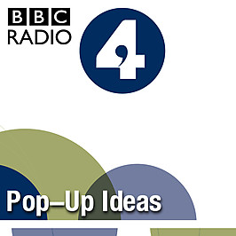
Tim Harford – in the company of Malcolm Gladwell, David Kilcullen and Gillian Tett – uses key ideas in anthropology and the social sciences to tell fascinating stories about how we - and the world – work.

Freakonomics http://itunes.apple.com/us/podcast/freakonomics-radio/id354668519

The Bottom Line with Evan Davis http://www.bbc.co.uk/podcasts/series/bottomline
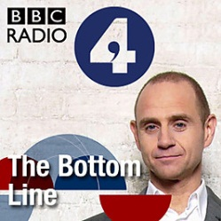
Insight into business from the people at the top. Evan Davis meets influential business leaders for a round table conversation about the issues that matter to their companies and their customers. The BBC produces two radio versions of this programme - one for the UK audience that can be heard on BBC Radio 4 on Thursday evenings at 20:30 GMT, and one for the international audience that can be heard on BBC World Service on Fridays at 22:06 GMT.

Analysis http://www.bbc.co.uk/podcasts/series/analysis
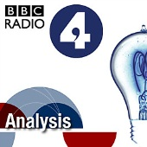
Analysis makes sense of the ideas that change the world. What made Islam political, whether the Government can make us go green, why we think the market in human organs is repugnant are just some of the subjects the series tackles. With thought-provoking and expert presenters, Analysis aims to make the world of policy and ideas both interesting and surprising. There are 26 episodes a year, in three series. Podcasts are available for a week after transmission while the programme is on air.

Reith Lectures http://www.bbc.co.uk/podcasts/series/reith
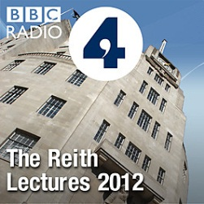
The economic historian Professor Niall Ferguson presents the 2012 BBC Reith Lectures, titled The Rule of Law and Its Enemies. Across four programmes he explores the role of man-made institutions on global economic growth and democracy, referencing the global economic crisis and financial regulation, as well as the Arab Spring. The first programme will be available to download on Tuesday, 19 June 2012.

Peter Day’s World of Business http://www.bbc.co.uk/programmes/p02nrwfk/episodes/downloads
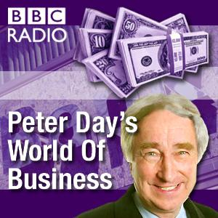
Insights into the business world with Peter Day - featuring content from BBC Radio 4's In Business programme, and also Global Business from the BBC World Service.

Tim Harford: Pop-Up Ideas BBC Radio 4

Tim Harford: Simon Garfield: Maps And Mistakes 01 Jan 2014
Simon Garfield on the mistakes and deceptions in some of our best-loved maps. "How boring would the world be," he asks, "if we knew precisely where everything was?"
Jared Diamond: How Geography Creates History 25 December 2013
The geographer and polymath Jared Diamond argues that apparently slight differences in geography can have profound consequences for the culture and history of nations.
Tim Harford: Jerry Brotton - Mapping History 18 Dec 2013
Professor Jerry Brotton argues that how we see the world depends entirely on where we stand on it and says each period in history gets the map it deserves.
Tim Harford: The Power Of Maps 11 Dec 2013
1/3. Tim Harford returns with a new series of Pop Up Ideas. This time Tim and his guests tell intriguing stories inspired by maps.
Tim Harford: Tragedy of the Commons 30 Jul 2013
Common Tragedy: Exploring the term 'The Tragedy of the Commons', a term coined by the American ecologist Garrett Hardin. Tim Harford compares Hardin's work to that of the American political economist Elinor Ostrom, to reflect on the impact of mankind on the world around us.
David Kilcullen: Feral Cities 23 Jul 2013s
Feral Cities: As a counter-insurgency expert David Kilcullen's idea have been described as 'revolutionizing military thinking throughout the West'. Here talks about how future instability will emanate from rapidly-growing coastal megacities.Through the personal story of a Somali commander he met in Mogadishu, David tells how the urban overstretch that tore Mogadishu apart in the 90s - is happening to cities all over Africa, Asia and Latin America.
Gillian Tett: The Anthropology of Economics 16 Jul 2013
The Anthropology of Economics: Having studied anthropology and living among Tajik families Gillian Tett went on to become a financial journalist. She describes how her background in anthropology led her to predict the financial crisis in 2008
Malcolm Gladwell: Listening in Vietnam 09 Jul 2013
Listening in Vietnam: Malcolm Gladwell tells the powerful story of how listening carefully could have shortened the Vietnam War.
Tim Harford: The day the geeks took over poker 13 Feb 2013
Tim tells the story of Chris Ferguson who applied game theory to poker and won - big time. But, as Ferguson would find out, there's always a bigger game.
Tim Harford: The Indiana Jones of Economics 06 Feb 2013
Tim Harford tells the story of Bill Phillips - war hero, engineer, crocodile-hunter, and one of the fathers of macro-economics.

Tim Harford: War Games and Armageddon 30 Jan 2013
Tim Harford tells the story of Thomas Schelling, an economist who helped America and the Soviet Union to avoid nuclear war.
Tim Harford: The Kidney Matchmaker 23 Jan 13
Tim tells the story of Al Roth, who worked out how to create a clearing-house for kidneys.
Tim Harford: Hotpants vs The Knockout Mouse 16 Jan 2013
Tim Harford weaves together economic ideas with remarkable personal histories in some unusual locations. The presenter of Radio 4's More or Less speaks to an audience from a shop window on London's Regent Street, and turns his attention to heated pants and the business of innovation. He tells the moving story of Mario Capecchi, whose struggle to get funding for his experiments tells us much about where new ideas come from, and how to foster them.

Analysis BBC Radio 4
Kenya’s Basic Income Experiment
https://www.bbc.co.uk/programmes/b0b2hq5v
What happens if you give every adult in a village $22 a month, no strings attached, for 12 years? In rural Kenya, researchers are trying to find out. They're conducting the world's largest study of 'universal basic income' - giving 'free money' to nearly 200 villages, to see whether this could kick-start development and bring people out of poverty. The BBC's Africa correspondent Anne Soy visits western Kenya to meet some of the people involved in this giant economic experiment, and to find out what they make of this unexpected windfall in their lives. How will people spend the money? Will they try to start businesses, or stay in education longer? Or will people stop working, now they have a guaranteed income? What impact will this have on the villages? The BBC intends to return to the same village over the course of the study, to continue to monitor and assess the impact of this 'basic income', and to see what difference it makes to peoples' lives, the choices they make, and the dreams they hold.

Making Invisibles Visible 15 June 2015
The UK is the world's second largest exporter of services - and has been for some time. The surplus generated by these "invisibles" - everything from banking to public relations to whizzy new phone
Company vs Country 30 March 2015
Michael Robinson asks what lies behind the boom in companies suing governments.
The End of Development 09 March 2015
In a lecture at the Blavatnik School of Government at Oxford University, anthropologist Professor Henrietta Moore argues that development is an outmoded concept.
When robots steal our jobs 02 Mar 2015
Technology has been replacing manufacturing jobs for years. Now it has white-collar jobs in its sights. David Baker asks what we will do if robots take over the workplace?
Downward Social Mobility 16 Feb 2015
Social mobility is a good thing – right? But movement can go in both directions. Jo Fidgen explores the implications of downward social mobility.
Precedents or Principles 17 Nov 2014
"I always buy this type of coffee." But is that decision one of principle -or just because you buy it each day? Nick Chater asks which matters more to us: precedent or principles?
Inside Welfare Reform 27 Oct 2014
How well has the government implemented its controversial welfare reforms? Have they been a vital check to a system spiralling out of control or - as some say - close to a fiasco?
Thrifty Debtors 21 July 2014
The downturn's made everyone worry more about money. But while we may want to be thriftier, Chris Bowlby discovers why we're stuck with high personal and household debt.
The End of the Pay Rise? 14 July 2014
Wages have fallen for most of us for the last six years in Britan, which is unprecedented. We’re told that there’s a return in economic growth and yet wages have still not picked up. What has happened? Is this a long term problem – is this the end of the pay rise? Paul Johnson, director of the Institute for Fiscal Studies, explores the mystery of our falling wages and how wages are shared out between the top earners and the rest of us.
Varieties of Capitalism 23 June 2014
Can a country switch between different models of capitalism? The Economist's Britain politics correspondent, Jeremy Cliffe, explores whether the proposals put forward by some British politicians to transform the UK's economy into one more akin to that of Germany, Denmark and Sweden is remotely possible - or are we stuck with what we've got?
Deirdre McCloskey 26 May 2014
Evan Davis interviews economic historian Deirdre McCloskey in front of an audience at the London School of Economics, where she argues that poverty matters more than inequality.
France: Sinking Slowly? 11 NOV 2013
The French are far more attached to the centralised, big state than their Anglo-Saxon counterparts. Former BBC Paris Correspondent Emma Jane Kirby asks if it is affordable.
Quantitative Easing: Miracle Cure or Dangerous Addiction? 21 Oct 2013
Could Quantitative Easing create a bigger financial crisis than the one it was supposed to avert? Sunday Telegraph economic commentator Liam Halligan argues that it could.
They're Coming For Your Money 08 July 2013
Paul Johnson of the Institute for Fiscal Studies argues that taxes look set to rise despite further spending cuts, and finds out which ones are likeliest to go up and who will pay.
Nudge theory in practice 25 March 2013
Governments should incentivise rather than force citizens to behave better, according to the book "Nudge". Author Cass Sunstein explains how governments have adopted his theories.
Vulgar Keynesians 25 Feb 2013
Radical American critics of the left's current thinking on the economy outline their critique to Tim Finch. Is it time for a rethink on the British left too?
Making the best of a bad job 18 Feb 2013
David Goodhart considers whether the declining status of basic jobs can be halted and even reversed. Successive governments have prioritised widening access to higher education to try to drive social mobility, without giving much thought to the impact this has on the expectations of young people who, for whatever reason, are not going to take that path. But even in a knowledge-based economy, low-skilled work survives. Offices still need to be cleaned, supermarket shelves stacked, and care home residents looked after. The best employers know how to design these jobs to make them more satisfying. Are politicians finally waking up to the problem?
Creative Destruction 11 Feb 2013
As high street names close for good, Analysis asks if such failures are necessary for future growth. Or is "creative destruction" a comforting delusion, not a saving grace?
A Scottish Pound? 28 Jan 2013
The cash question facing an independent Scotland. Chris Bowlby discovers the key role of currency in debate about the UK's political future.
Labour, the left and Europe 29 Oct 2012
A Eurosceptic Labour Party might seem unthinkable. But the European Union is changing and so too should Labour’s attitude towards it, argues Labour MP Gisela Stuart. She reveals to presenter Edward Stourton that she now believes Britain would be better off outside the EU. Her party continues to maintain a pro-European face but, Edward Stourton learns, the Labour leadership is preparing to recalibrate its policy as the Europe of workers’ rights gives way to the Europe of austerity and fiscal federalism.
Alternative economic cultures 15 Oct 2012
Professor Manuel Castells says the current financial crisis is more than just an economic downturn. The causes are so deep rooted that they have provoked a profound reassessment of our economic beliefs and institutions and given rise to new protest movements and economic cultures.
Keeping the free market faith 08 Oct 2012
Free market capitalism has fallen into disrepute. Even the British Conservative party is blaming the financial crisis on unfettered markets. Jamie Whyte thinks they are wrong.
Analysis Extra: The EU Debate 08 AUG 2012
Should Britain stay in the European Union? With the crisis continuing in the eurozone, recent polls suggest that the vast majority of the British electorate would be in favour of a referendum on Britain's membership of the European Union. Evan Davis chairs a debate at the London School of Economics, and is joined by Sir Stephen Wall. The former diplomat and EU adviser to Tony Blair argues his position for Britain to remain in the EU against a panel which wants Britain out.
The Gold Standard 02 JUL 2012
Paper money versus gold backed currencies. Simon Jack asks if our financial system would be more stable if money was pegged to gold rather than created at the touch of a button by private and central banks
Eurogeddon II 25.06.12
Disintegration or superstate? As the crisis deepens in the Eurozone, Chris Bowlby imagines the EU's future. What will happen to borders, cash movements and political power?
Steve Keen - why economics is bunk 4 May 2012
Newsnight Economics Editor Paul Mason interviews the controversial economist Steve Keen before an audience at the LSE. Keen was one of the few who predicted the 2008 crash.
Preparing for Eurogeddon 20.05.12
As Greece teeters on the brink of ejection from the Eurozone, Chris Bowlby reveals the scenarios likely to follow a return to the Drachma. Originally broadcast in February 2012
What is money? 26 Mar 12
Is the value of money determined by anything more than our willingess to believe in it? Frances Stonor Saunders tries to understand the fundamentals.
Profits before pay 20 Feb 12
Wages have failed to rise in line with profits since the early 1980s. Duncan Weldon, a senior economist at the Trades Union Congress, goes in search of the possible causes.
Capitalists against the Super Rich 23 Jan 12
Defenders of capitalism are turning against the undeserving rich. Edward Stourton asks those on the centre-right who now condemn financial excess, what they would actually change?
Analysis Extra: Divorcing Europe 12 Dec 11
EU withdrawal is being seriously discussed for the first time in a generation. But how would it work? In a programme previously broadcast on 16 November 2009, Analysis looks at the Lisbon Treaty, which contains a clause setting out an exit process. But, as Chris Bowlby reports, the final deal between Britain and its former EU partners would depend a lot on the mood of their "divorce" - amicable or acrimonious. We hope you enjoy this programme - which we offer you while Analysis is off air.

Analysis Extra: Martin Wolf: New Global Economics 2 21 Nov 11
Martin Wolf, chief economics commentator of the Financial Times asks what changes are neeeded to the global financial system if the world is to fully recover from the worst economic crisis since the depression of the 1930s. Contributors include: Larry Summers, of Harvard and former member of Barack Obama's economic team; Zhu Min, deputy managing director, IMF and formerly of the Bank of China and Adair Turner, FSA chairman. Producer: Sandra Kanthal Editor: Stephen Chilcott
Analysis Extra: Martin Wolf: New Global Economics 1 14 Nov 11
Martin Wolf, chief economics commentator of the Financial Times, examines how the world economy has changed since the beginning of the financial crisis four years ago. Contributors include US Treasury Secretary Timonthy Geithner, IMF managing director Christine Lagarde and FSA chairman Adair Turner. Producer: Sandra Kanthal Editor: Stephen Chilcott
Euroscepticism Uncovered 17 Oct 11
As opinion polls suggest that half of Britons would vote to leave Europe altogether, Edward Stourton asks if the political class is now catching up with public opinion on the EU. The programme hears from several Eurosceptic Conservative MPs who feel that the issue is so sensitive that they want to remain anonymous. Edward Stourton also questions Conservative Home's Tim Montogomerie, former Chancellor Norman Lamont, Blue Labour peer Lord Glasman, and Director of the People's Pledge Mark Seddon."
Keynes vs Hayek - The LSE Debate 3 AUG 2011
John Maynard Keynes and Friedrich Hayek are regarded as two of the twentieth century’s greatest economists. Modern day followers came together at the London School of Economics to debate the ideas of their intellectual heroes. The event was chaired by BBC Newsnight Economics Editor, Paul Mason.
Radical Economics: escaping credit serfdom: 07 Feb 11
Paul Mason asks whether the expansion of credit created a new form of worker exploitation.
Yo Hayek! 31 Jan 11
Jamie Whyte looks at the free market Austrian School of FA Hayek. The global recession has revived interest in this area of economics, even inspiring an educational rap video.
The Economist: Left Behind – The issues and those left behind by globalisation
https://www.economist.com/briefing/2017/10/21/globalisation-has-marginalised-many-regions-in-the-rich-world

Blogs

Mainly Macro http://mainlymacro.blogspot.co.uk/
Simon Wren-Lewis: economics professor at Oxford University, and a fellow of Merton College

http://bankunderground.co.uk/
A blog by staffers at the Bank of England

https://longandvariable.wordpress.com/
A blog on macroeconomics and public policy by Tony Yates

http://karlwhelan.com/blog/

Free exchange http://www.economist.com/blogs/freeexchange

Economics

http://krugman.blogs.nytimes.com/

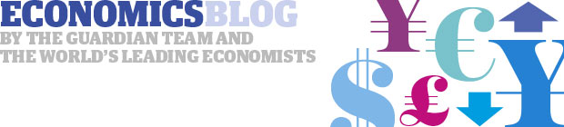
http://www.theguardian.com/business/economics-blog

http://gregmankiw.blogspot.co.uk/

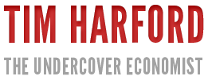 http://timharford.com/

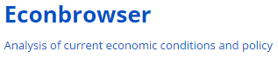 http://econbrowser.com/

http://fatasmihov.blogspot.co.uk/
http://beta.tutor2u.net/

Daily chart
Irrational exuberance
Jun 17th 2015, 19:12 BY THE DATA TEAM
AMERICA'S central bank, the Federal Reserve, is one of the most powerful economic institutions in the world. Its decisions to raise or lower interest rates can roil markets and change the trajectory of economic growth. But the Fed's main interest rate fell to near zero in 2008, and since 2012 Fed officials have tried to prepare markets for eventual rate hikes by using “dot-plots”. These mysterious charts show where Fed members think the benchmark interest rate will sit over the next few years. When a new dot-plot is published, investors puzzle over it in an attempt to divine its cryptic meaning. The interactive charts that follow explain the dot-plots in depth.
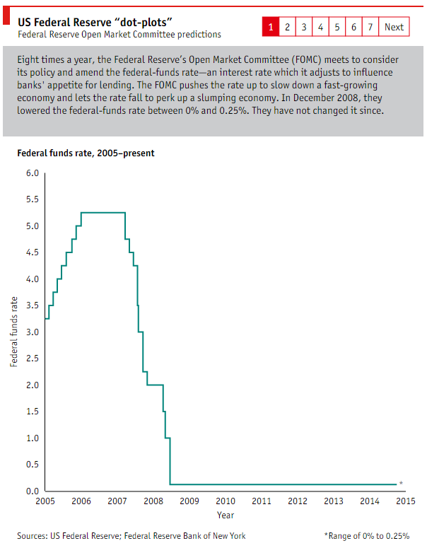

University lectures

Cambridge http://www.sms.cam.ac.uk/

LSE http://www2.lse.ac.uk
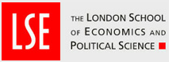

Open University http://podcast.open.ac.uk/

Oxford http://podcasts.ox.ac.uk/

Yale http://itunes.yale.edu/

Coursera

https://www.coursera.org/
Berklee College of Music
Brown University
California Institute of Technology
Columbia University
Duke University
École Polytechnique Fédérale de Lausanne
Emory University
Georgia Institute of Technology
Hebrew University of Jerusalem
Johns Hopkins University
Mount Sinai School of Medicine
Ohio State University
Princeton University
Rice University
Stanford University
The Hong Kong University of Science and Technology
The University of British Columbia
University of California, Irvine
University of California, San Francisco
University of Edinburgh
University of Florida
University of Illinois at Urbana-Champaign
University of London International Programmes
University of Maryland, College Park
University of Melbourne
University of Michigan
University of Pennsylvania
University of Pittsburgh
University of Toronto
University of Virginia
University of Washington
Vanderbilt University
Wesleyan University

Recent disputes in economics – Summer 2015

New Keynesians Neo-liberals
Simon Wren Lewis Niall Ferguson

Links

http://www.project-syndicate.org/commentary/the-economic-consequences-of-mr-osborne-by-niall-ferguson-2015-05

http://mainlymacro.blogspot.co.uk/2015/05/ferguson-tries-again.html

79 Economists George Osborne
Letter to the Guardian
http://www.theguardian.com/politics/2015/jun/12/osborne-plan-has-no-basis-in-economics
Simon Wren Lewis
http://mainlymacro.blogspot.co.uk/2015/06/signing-letters.html
Philip Booth
http://www.iea.org.uk/blog/closed-minded-economists

