BTEC L3 Sport and exercise science (Extended Diploma)
This pack contains a programme of activities and resources to prepare you to start BTEC Level 3 in September. It is aimed to be used after you complete your GCSE throughout the remainder of the summer term and over the summer holidays too ensure you are ready for Level 3 study in September.
You will be required to hand in this work during the first lesson – so bring it with you on your first day please. If you are unsure of expectations/success criteria please discuss it with one of the PE teachers PRIOR (not directly) to your presentation date.
We highly recommend you purchase one of the BTEC text books so you are able to fully utilise them during the course. They are;
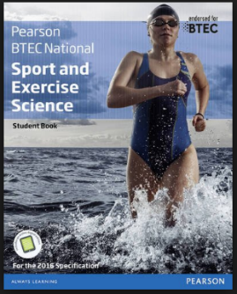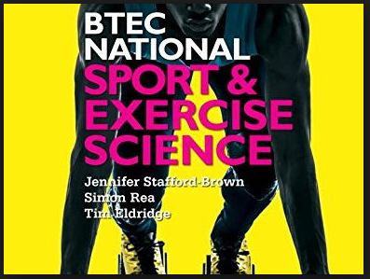
For external examinations;
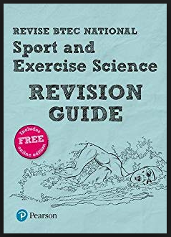
Use the BTEC website - https://qualifications.pearson.com/en/qualifications/btec-nationals/sport-and-exercise-science-2016.html
Follow the link above OR navigate through subject/nations/sports and exercise science 2017/extended diploma
1. | What does GLH stand for?
2. | What modules are assessed in an exam style/externally?
3. | What other modules will you study?
4. | What is an assignment brief?
5. | What is unit content and where will you find it?
6. | What qualities do you think you need to be successful in BTEC
7. | What is your aspired grade?
8. | What would you like to do after the course?
9. | Choose a topic area from the following;  - Cardiovascular system  - Skeletal system  - Principles of nutrition and hydration – basic nutritional principles  - Principles of nutrition and hydration – macronutrients  Now complete comprehensive ‘Cornell Notes’ to hand in on your first lesson in September.  You will need to research what ‘Cornell Notes’ are first. There are plenty of videos out there. type in to a search engine “what are Cornell Notes”

Success criteria (those by which you will be assessed on for each selected skill)
- Ability to use the correct format (5)
- Include all notes so use the unit content in the specification (5)
- Summary shows an explanation of the notes. Showing more detail. (5)

