A level Physical Education
This pack contains a programme of activities and resources to prepare you to start A Level PE in September. It is aimed to be used after you complete your GCSE throughout the remainder of the summer term and over the summer holidays too ensure you are ready for A Level study in September.
In your first few weeks in the autumn term at QEGS you will complete a presentation based on the work you have completed this summer. Failure to demonstrate your completion of the summer work in this presentation could lead to discussions on whether A Level PE is a suitable option for you. If you are unsure of expectations/success criteria please discuss it with one of the PE teachers PRIOR (not directly) to your presentation date.
We highly recommend you purchase the A Level PE text books so you are able to fully utilise them during the course. They are;
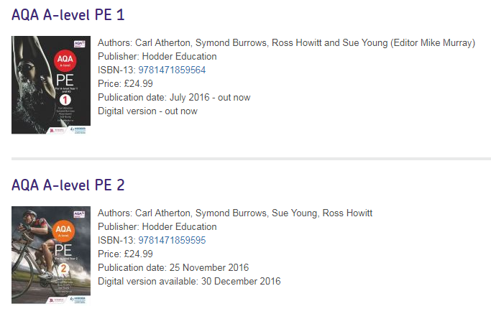
Use the AQA website - https://www.aqa.org.uk/
Find the answers to the following questions regarding the specification (A Level PE 7582).
1. | Using 2.1 from the specification list the 7 subject areas of study
2. | What is assessed in paper 1 and how much of the final grade is it worth?
3. | What is assessed in paper 2 and how much of the final grade is it worth?
4. | What is ‘synoptic assignment’?
5. | What does NEA stand for?
6. | How much is the NEA worth for the overall grade?
7. | What are you expected to do for the NEA?
8. | What sport will you focus on for the NEA?
9. | Using the specification look at the core skills for your chosen sport. Copy out the core and advanced skills and grade yourself out of 5 for each skill. Remember this will be a game situation, not practices isolation.
10. | You must video 4/5 performances from start to finish (unedited). What means do you have to record?
11. | Name and date games/competitions you are able to record over the next year please.

Now you are familiar with the course please complete the following task. You will be expected to present in the first few weeks of school. Please be prepared. You may use PowerPoint or equivalent to help your verbal analysis and evaluation.
Choose 1 skill from each area of assessment (attacking, defending and/or tactical) and analyse and evaluate your performance in a chosen performance specifically or in general.
Success criteria (those by which you will be assessed on for each selected skill)
- Identify a weakness from the selected skills, this should be the weakness that has the biggest impact on performance/result (5)
- Use practical examples to show the impact (5)
- What would be the impact on the skill if you improved it? (5)
- Use of appropriate and technical language (5)
Feel free to use this table to help you structure your response.
Person being analysed | Activity performed
Area of assessment: | Weakness identified:
Background information (e.g. where appropriate, who were you performing against? What was happening at the time/what was the score/how had you been performing?)
Type here
Technical explanation of the weakness and the impact this weakness had on the performance (this will be the physical description of the action):
Type here

(This table should be repeated three times. One for each area of assessment)

